Most Influential Scientific Inventions
Discoveries, and Innovations in Human History
An Expanded Reference with Historical Context, Scientific Significance, and Multimedia Resources

EXECUTIVE SUMMARY This document examines sixty landmark inventions, scientific discoveries, and technological innovations that have had a decisive impact on humanity. For each entry, it provides historical context, an assessment of scientific and technological significance, an account of societal and civilisational impact, and curated links to reliable multimedia resources — documentaries, lectures, interactive databases, peer-reviewed papers, and museum collections — to support further study.

Contents
1. Foundational Civilisational Innovations (9 entries)
2. Knowledge, Science, and Measurement (4 entries)
3. Industrial, Energy, and Transport Revolutions (7 entries)
4. Medicine, Biology, and Public Health (9 entries)
5. Physics, Chemistry, and Materials Science (6 entries)
6. Digital, Space, and Communication Technologies (17 entries)
7. Emerging and Transformative Technologies (8 entries)
8. Concise Top 20 Summary

Overview by Category
Category | Items | Examples
Foundational Civilisational Innovations | 9 | Controlled fire, Agriculture, Wheel, Writing, Mathematics, Paper, Compass, Gunpowder, Printing press
Knowledge, Science, and Measurement | 4 | Scientific method, Telescope, Microscope, Newtonian mechanics
Industrial, Energy, and Transport Revolutions | 7 | Steam engine, Electricity, Electromagnetism, ICE, Automobile, Airplane, Refrigeration
Medicine, Biology, and Public Health | 9 | Vaccination, Antibiotics, Germ theory, Anaesthesia, X-rays, Sanitation, DNA, Genome, CRISPR
Physics, Chemistry, and Materials Science | 6 | Periodic table, Quantum mechanics, Relativity, Nuclear energy, Plastics, Fertilisers
Digital, Space, and Communication Technologies | 17 | Telegraph, Telephone, Radio, Transistor, IC, Computer, Internet, Web, Search, Satellite, GPS, Semiconductors, Laser, Fibre optics, Spaceflight, Smartphones, Social media
Emerging and Transformative Technologies | 8 | Artificial intelligence, Renewable energy, Batteries, Electric vehicles, Robotics, 3D printing, Blockchain, Cloud computing

1. Foundational Civilisational Innovations

Controlled Use of Fire
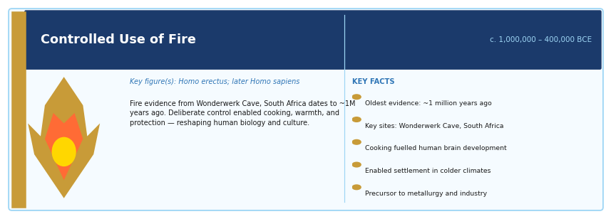
Period: c. 1,000,000 – 400,000 BCE | Key figure(s): Homo erectus (earliest evidence); later Homo sapiens
HISTORICAL CONTEXT
Archaeological evidence from sites such as Wonderwerk Cave (South Africa) and Qesem Cave (Israel) shows that hominins were using fire at least one million years ago. Consistent, deliberate control of fire appears from around 400,000 BCE. Early humans likely acquired fire from natural sources — lightning strikes, volcanic activity — before learning to produce it through friction or percussion.
SCIENTIFIC / TECHNOLOGICAL SIGNIFICANCE
Fire is arguably the foundational technology of human civilisation. It enabled cooking, which made food safer, more digestible, and more nutritious, driving increases in caloric intake that may have supported brain development. Fire provided warmth and protection against predators, extended productive hours beyond daylight, and was later essential for metallurgy, pottery, ceramics, glass-making, and every subsequent industrial process.
IMPACT ON HUMANITY
The Harvard anthropologist Richard Wrangham argued in 'Catching Fire' (2009) that cooking with fire was a primary driver of human evolution itself. Beyond biology, fire enabled humanity's spread to colder climates, the development of social gathering and storytelling around hearths, and eventually every heat-dependent technology from iron smelting to the steam engine to modern energy systems. The control of fire is often cited as the moment humans first reshaped their environment deliberately.
MULTIMEDIA & FURTHER RESOURCES
▸ BBC: The Discovery of Fire — A Short Documentary — BBC archive
▸ Richard Wrangham: How Cooking Made Us Human (TED-style lecture, Harvard) — YouTube
▸ Smithsonian Human Origins: Use of Fire — Smithsonian Institution
▸ Nature article: Evidence of fire at Wonderwerk Cave — Nature

Agriculture and Domestication
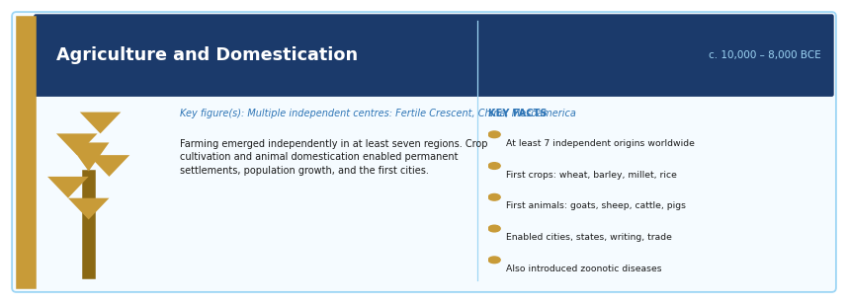
Period: c. 10,000 – 8,000 BCE | Key figure(s): Multiple independent centres: Fertile Crescent, China, Mesoamerica, Africa
HISTORICAL CONTEXT
The Neolithic Agricultural Revolution did not happen in one place. It emerged independently in at least seven distinct regions — including the Fertile Crescent (wheat, barley), China (millet, rice), Mesoamerica (maize), and sub-Saharan Africa (sorghum). The domestication of animals — goats, sheep, cattle, pigs, horses — closely followed or accompanied plant cultivation. This transition from foraging to farming is one of the most debated episodes in human history.
SCIENTIFIC / TECHNOLOGICAL SIGNIFICANCE
Agriculture allowed humans to produce food surpluses, which in turn enabled permanent settlement, population growth, specialisation of labour, social hierarchies, taxation, writing, monumental architecture, and standing armies. The domestication of animals provided traction, transport, fibre, milk, and meat, and also, tragically, introduced many infectious diseases to humans (influenza, smallpox, measles) that would devastate populations for millennia.
IMPACT ON HUMANITY
The Agricultural Revolution fundamentally altered human biology, society, health, and environment. It is the precondition for all subsequent civilisation — cities, states, empires, science, philosophy, and art. Jared Diamond's 'Guns, Germs, and Steel' and James C. Scott's 'Against the Grain' both offer influential — and contrasting — analyses of why agriculture arose and what it cost human populations in health and freedom.
MULTIMEDIA & FURTHER RESOURCES
▸ National Geographic: Origins of Agriculture — National Geographic
▸ Khan Academy: The Agricultural Revolution — Free course
▸ PBS Eons: How Agriculture Changed the World (YouTube) — YouTube
▸ Jared Diamond on 'The Worst Mistake in the History of the Human Race' — Discover Magazine

The Wheel
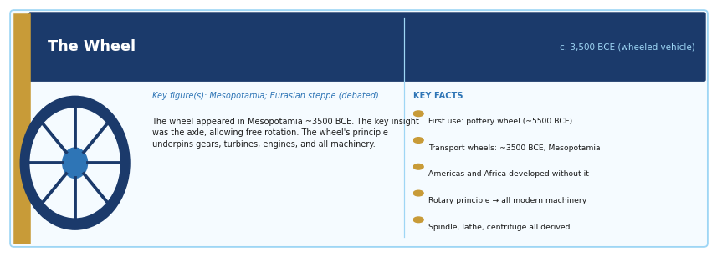
Period: c. 3,500 BCE (wheeled vehicle); c. 5,500 BCE (potter's wheel) | Key figure(s): Mesopotamia and the Eurasian steppe (multiple independent inventions debated)
HISTORICAL CONTEXT
The earliest evidence of the wheel used for transport comes from Mesopotamia around 3500 BCE, though the potter's wheel likely preceded it. Remarkably, the Americas, sub-Saharan Africa, and Australia developed complex civilisations without the wheel, demonstrating that it was not an inevitable invention. The key innovation was not the wheel itself but the axle — the mechanism allowing the wheel to rotate freely.
SCIENTIFIC / TECHNOLOGICAL SIGNIFICANCE
The wheel enabled wheeled vehicles, transforming the capacity of trade, warfare, and agriculture across Eurasia. Its rotary principle underpins the gear, the pulley, the water wheel, the mill, the clock, the turbine, the engine flywheel, and the modern drivetrain. It also gave rise to the spindle, the lathe, and the centrifuge. The wheel is less a single object than the discovery of a fundamental mechanical principle.
IMPACT ON HUMANITY
Wheeled transport reduced the cost and time of moving goods across long distances, enabling larger trade networks and empires. In the industrial era, the wheel's principle became central to nearly all machinery. Today, rotary motion — from hard drives to jet engines to wind turbines — underpins virtually all mechanical technology.
MULTIMEDIA & FURTHER RESOURCES
▸ Smithsonian Magazine: Who Invented the Wheel? — Smithsonian
▸ TED-Ed: The History of the Wheel (Animation) — YouTube

Writing Systems
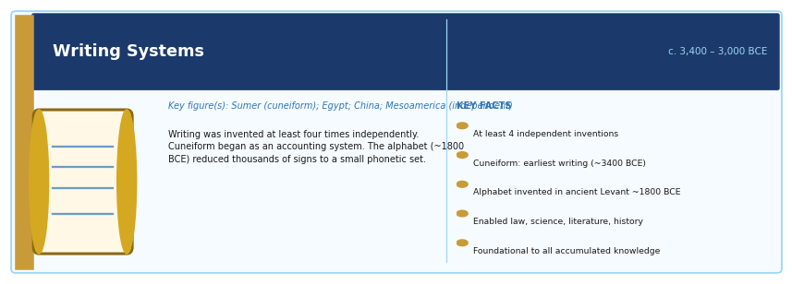
Period: c. 3,400 – 3,000 BCE (Sumerian cuneiform); c. 3,200 BCE (Egyptian hieroglyphs) | Key figure(s): Sumer (cuneiform); Egypt (hieroglyphs); China and Mesoamerica (independent inventions)
HISTORICAL CONTEXT
Writing was invented at least four times independently — by the Sumerians, Egyptians, Chinese, and the Maya. Cuneiform, pressed into clay tablets, began as an accounting system for tracking grain and livestock. The alphabet, first appearing in the ancient Levant around 1800 BCE, was one of the great simplifications: it reduced thousands of signs to a small set of phonetic symbols that any literate person could learn.
SCIENTIFIC / TECHNOLOGICAL SIGNIFICANCE
Writing makes it possible to transmit knowledge across time and space with precision. It enabled the codification of laws (Hammurabi's Code), the preservation of religious texts, scientific observation, literature, contracts, diplomacy, and history. Without writing, accumulated knowledge cannot be reliably passed between generations; with it, civilisation becomes cumulative.
IMPACT ON HUMANITY
Writing is arguably the most enabling meta-technology in history — the tool that makes all other knowledge tools possible, from libraries to universities to the internet. Every scientific paper, legal code, economic record, and literary work depends on writing. It also created new forms of power: literacy and record-keeping have historically been instruments of both liberation and control.
MULTIMEDIA & FURTHER RESOURCES
▸ The British Museum: History of Writing (online resource) — British Museum
▸ TED-Ed: The History of Writing (Animation) — YouTube
▸ Omniglot: Writing Systems of the World — Reference

Mathematics and the Concept of Zero
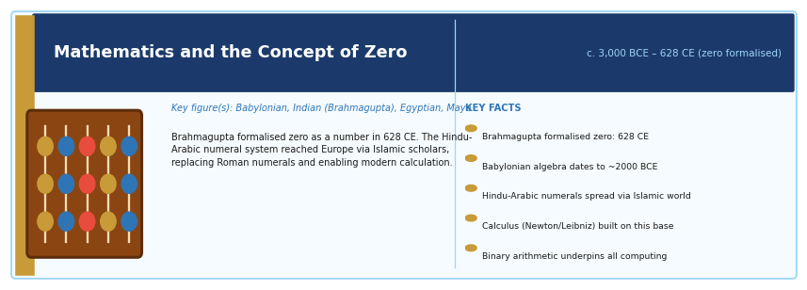
Period: c. 3,000 BCE (counting systems); 628 CE (Brahmagupta formalises zero) | Key figure(s): Babylonian, Egyptian, Indian (Brahmagupta), and Maya mathematicians
HISTORICAL CONTEXT
Mathematics evolved in parallel with writing and trade — Babylonian clay tablets from 2000 BCE contain algebraic problems and approximations of pi. The concept of zero as a number (not just a placeholder) was first formalised by the Indian mathematician Brahmagupta in the 7th century CE. The Hindu-Arabic numeral system, which includes zero and place value, was transmitted to Europe via Islamic scholars by the 12th century, replacing Roman numerals.
SCIENTIFIC / TECHNOLOGICAL SIGNIFICANCE
Mathematics is the language of science, engineering, finance, and computing. The positional number system with zero enabled complex arithmetic, algebra, calculus, statistics, and ultimately the binary arithmetic that underlies all digital computing. Calculus (developed independently by Newton and Leibniz) made physics, engineering, and economics mathematically tractable. Without mathematics, no scientific theory, no algorithm, no structure could be precisely stated.
IMPACT ON HUMANITY
Mathematics is the hidden infrastructure of modernity. GPS systems use differential equations; financial markets are driven by stochastic models; AI is built on linear algebra and calculus. The development of statistics and probability theory made epidemiology, insurance, scientific experiment design, and machine learning possible. Every digital device, from smartphones to satellites, computes using binary arithmetic derived from mathematical logic.
MULTIMEDIA & FURTHER RESOURCES
▸ BBC Documentary: The Story of Maths (BBC Four, Marcus du Sautoy) — BBC
▸ TED-Ed: The History of Zero — YouTube
▸ MacTutor History of Mathematics (University of St Andrews) — Academic resource

Paper
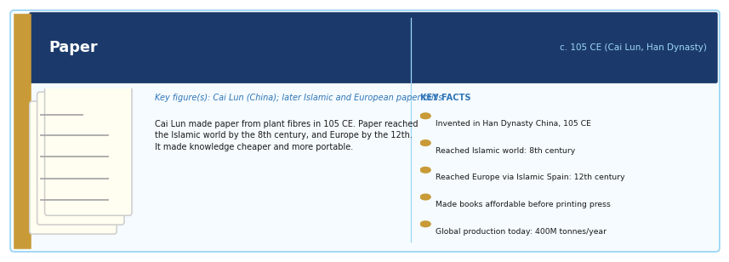
Period: c. 105 CE (official Chinese invention attributed to Cai Lun); spread to Europe by 12th century | Key figure(s): Cai Lun (Han Dynasty China); later Islamic and European paper mills
HISTORICAL CONTEXT
Before paper, writing materials included stone, clay tablets, papyrus (expensive, fragile), parchment (costly animal skin), and wooden tablets. Cai Lun's paper, made from plant fibres (bark, hemp, rags), was cheaper, lighter, and easier to produce than any predecessor. Paper reached the Islamic world via Central Asia around the 8th century, and Europe through Islamic Spain by the 12th century.
SCIENTIFIC / TECHNOLOGICAL SIGNIFICANCE
Paper made information recording cheap. It enabled the mass copying of texts before the printing press, bureaucratic governance, scientific notation, mathematical workings, maps, art, and correspondence. When combined with the printing press, paper became the medium for the first mass communication revolution. Without affordable paper, neither the Scientific Revolution nor the Enlightenment could have unfolded as they did.
IMPACT ON HUMANITY
Paper underpinned the spread of literacy, religion, law, and science across Eurasia for over a thousand years before digital media. Even today, paper remains one of the most widely produced materials: global paper production exceeds 400 million tonnes per year. Paper is also the substrate on which money, legal contracts, and academic degrees are still often formalised.
MULTIMEDIA & FURTHER RESOURCES
▸ Smithsonian Magazine: The History of Paper — Smithsonian
▸ Library of Congress: Paper — An Overview — Library of Congress

The Compass
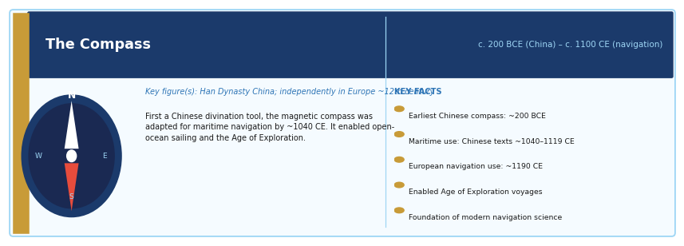
Period: c. 200 BCE (early Chinese lodestone compass); c. 1100 CE (navigational use in Europe and China) | Key figure(s): Han Dynasty China; independently developed in Europe c. 12th century
HISTORICAL CONTEXT
The magnetic compass was first described in China around 200 BCE as a divination tool. Its use for navigation at sea appeared in Chinese texts around 1040–1119 CE and in European texts around 1190 CE. Whether it spread from China to Europe or was independently rediscovered remains debated among historians. The dry compass with a pivoting needle in a housing was a European refinement of the 14th century.
SCIENTIFIC / TECHNOLOGICAL SIGNIFICANCE
The compass allowed sailors to navigate with confidence beyond sight of coastlines and stars. This enabled open-ocean voyaging — the defining technological precondition for the Age of Exploration. Without the compass, the Portuguese rounding of Africa, Columbus's Atlantic crossing, Magellan's circumnavigation, and the subsequent global expansion of trade, colonisation, and cultural contact would have been far more difficult or much later.
IMPACT ON HUMANITY
The Age of Exploration, made possible partly by the compass, reshaped the world permanently: it connected previously isolated continents, initiated global trade networks, spread diseases that devastated indigenous populations, created the Atlantic slave trade, and eventually produced the global economic system of today. The compass also influenced clock-making, precise surveying, and navigation science.
MULTIMEDIA & FURTHER RESOURCES
▸ National Museum of American History: The Compass — Smithsonian
▸ MIT OpenCourseWare: History of Navigation and Exploration — MIT OCW

Gunpowder
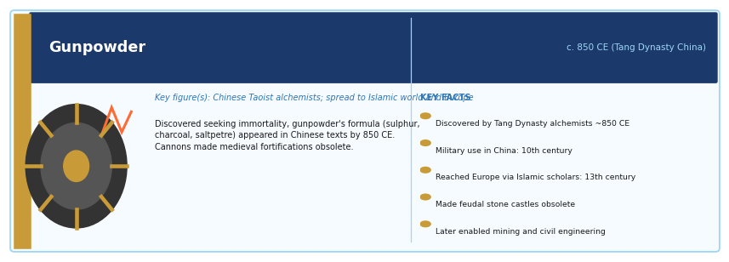
Period: c. 850 CE (Chinese alchemical discovery); widespread military use from c. 1000 CE | Key figure(s): Chinese alchemists (Tang Dynasty); spread to Islamic world and Europe by 13th century
HISTORICAL CONTEXT
Gunpowder was discovered by Chinese Taoist alchemists searching for an elixir of immortality — an ironic origin for one of history's most lethal inventions. The formula (sulphur, charcoal, saltpetre) appeared in Chinese texts by 850 CE. By the 10th century it was being used in Chinese fire-arrows and bombs. Knowledge reached the Islamic world by the 13th century and Europe shortly after, transformed by Roger Bacon's writings and then by European military engineers.
SCIENTIFIC / TECHNOLOGICAL SIGNIFICANCE
Gunpowder fundamentally altered warfare, siege technology, mining, quarrying, and later civil engineering. Cannons made medieval stone fortifications obsolete, contributing to the decline of feudalism. Firearms changed the relationship between infantry and cavalry, between common soldiers and aristocratic knights, and ultimately between states and their populations. Controlled explosives also enabled mining, tunnel construction, and road-building in hard rock.
IMPACT ON HUMANITY
The military, political, and economic consequences of gunpowder shaped the modern world order. The states that mastered firearms and artillery gained decisive military advantages, driving European global expansion. Later, the principles of controlled explosive combustion underpinned the internal combustion engine and modern mining, dam construction, and civil engineering.
MULTIMEDIA & FURTHER RESOURCES
▸ BBC History: The History of Gunpowder — BBC
▸ PBS: Secrets of the Dead — China's Terracotta Warriors (includes gunpowder history) — PBS

The Printing Press
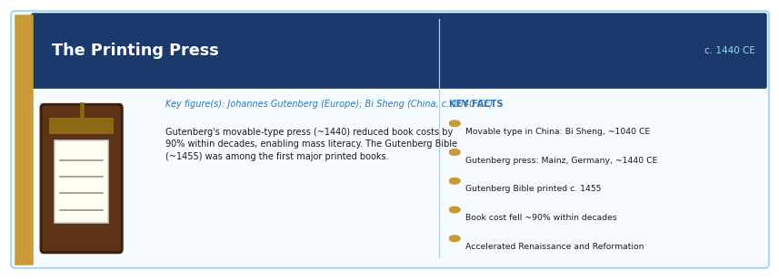
Period: c. 1440 CE (Gutenberg's movable-type press in Europe); movable type in China c. 1040 CE | Key figure(s): Johannes Gutenberg (Europe); Bi Sheng (China, c. 1040 CE, earlier movable type)
HISTORICAL CONTEXT
Movable type was invented in China by Bi Sheng around 1040 CE, and was later developed in Korea. Gutenberg's innovation around 1440 was a system adapted for the Latin alphabet, combining a metal alloy for durable type, an oil-based ink that adhered to metal, and a screw press adapted from wine and olive presses. His Gutenberg Bible (c. 1455) was one of the first major books produced with this system in Europe.
SCIENTIFIC / TECHNOLOGICAL SIGNIFICANCE
Before the printing press, each book had to be copied by hand — a process taking months, affordable only to the wealthy or the Church. The press reduced the cost of books by over 90% within decades and made mass literacy economically viable for the first time. It enabled the rapid dissemination of scientific work, religious reform (Martin Luther's 95 Theses spread across Europe within weeks), political thought, and eventually newspapers.
IMPACT ON HUMANITY
The printing press accelerated the Renaissance, the Protestant Reformation, the Scientific Revolution, the Enlightenment, and the development of national languages. Elizabeth Eisenstein's landmark study 'The Printing Press as an Agent of Change' (1979) documents how print culture transformed the nature of knowledge, authority, and public life. The press was the first mass-communication technology and a direct ancestor of modern media.
MULTIMEDIA & FURTHER RESOURCES
▸ British Library: Gutenberg Bible Online — British Library
▸ TED-Ed: How the Printing Press Changed the World (Animation) — YouTube
▸ Getty Museum: The Printing Press — History and Significance — Getty Museum
▸ PBS Documentary: Gutenberg and the Printing Revolution — PBS

2. Knowledge, Science, and Measurement

The Scientific Method
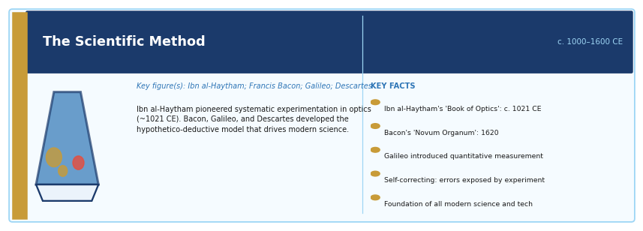
Period: c. 1000–1600 CE (development from Ibn al-Haytham to Bacon, Galileo, Descartes) | Key figure(s): Ibn al-Haytham (optics, c. 1021); Francis Bacon; Galileo Galilei; René Descartes
HISTORICAL CONTEXT
The scientific method did not appear suddenly. Ibn al-Haytham's 'Book of Optics' (c. 1021 CE) pioneered systematic experimentation and sceptical inquiry. Francis Bacon's 'Novum Organum' (1620) articulated inductive reasoning from evidence. Galileo introduced quantitative measurement and mathematical modelling of physical phenomena. René Descartes formalised deductive reasoning and the hypothetico-deductive model. Together they created a new way of producing reliable knowledge.
SCIENTIFIC / TECHNOLOGICAL SIGNIFICANCE
The scientific method — characterised by systematic observation, reproducible experiment, hypothesis formation, quantitative measurement, peer review, and openness to revision — is the most powerful knowledge-producing system ever developed. It is self-correcting: errors are exposed by further experiment rather than protected by authority. This distinguishes it from tradition, revelation, or authority as sources of knowledge.
IMPACT ON HUMANITY
Modern medicine, engineering, physics, chemistry, biology, computing, and virtually all technology rest on scientific method. Without it, the discoveries of Newton, Darwin, Pasteur, Einstein, Crick, and Watson — and every vaccine, drug, aircraft, and computer — would have been impossible. The scientific method is one of the most consequential intellectual achievements in history.
MULTIMEDIA & FURTHER RESOURCES
▸ Crash Course: The Scientific Method (YouTube) — YouTube
▸ Stanford Encyclopedia of Philosophy: Scientific Method — SEP
▸ PBS: The History of the Scientific Revolution — PBS Nova

The Telescope
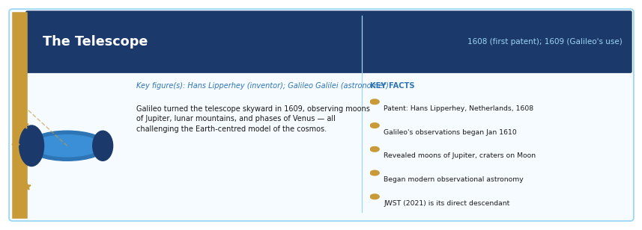
Period: 1608 (first patent, Netherlands); 1609 (Galileo's astronomical use) | Key figure(s): Hans Lipperhey (inventor, Netherlands); Galileo Galilei (first systematic astronomical use)
HISTORICAL CONTEXT
The telescope was patented by the Dutch spectacle-maker Hans Lipperhey in 1608, though several contemporaries may have assembled similar devices independently. Galileo, hearing of the invention, built his own and turned it skyward in 1609. He observed mountains on the Moon, four moons of Jupiter, phases of Venus, and resolved the Milky Way into individual stars. Each observation challenged the Ptolemaic model of the cosmos.
SCIENTIFIC / TECHNOLOGICAL SIGNIFICANCE
The telescope transformed astronomy from a mathematical and philosophical discipline into an observational science. It provided evidence for heliocentrism, revealed the scale and complexity of the universe, and gave humanity its first empirical view of other worlds. Later telescope types — reflecting, radio, space-based (Hubble, Webb) — extended the range of observation across the entire electromagnetic spectrum and to the edge of the observable universe.
IMPACT ON HUMANITY
The telescope inaugurated modern cosmology and astrophysics. It revealed that Earth is one of many worlds, that the universe is unimaginably vast and old, and that the laws of physics apply uniformly throughout. The James Webb Space Telescope, launched in 2021, is now capturing images of galaxies formed 200 million years after the Big Bang — a direct technological descendant of Galileo's instrument.
MULTIMEDIA & FURTHER RESOURCES
▸ NASA: History of the Telescope — NASA
▸ ESA/Hubble: Hubble Space Telescope Image Gallery — ESA/Hubble
▸ JWST Image Gallery (James Webb Space Telescope) — NASA/ESA/CSA
▸ Crash Course Astronomy: Telescopes (YouTube) — YouTube

The Microscope
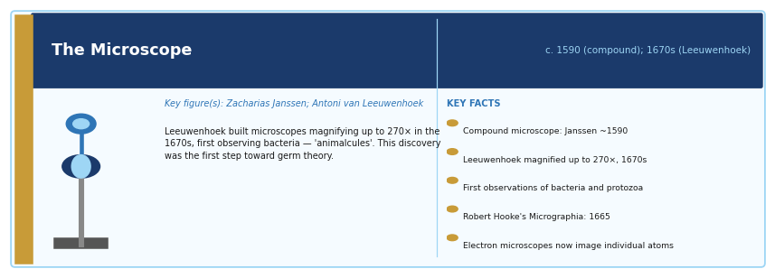
Period: c. 1590 (earliest compound microscope); 1670s (Antoni van Leeuwenhoek's improvements) | Key figure(s): Zacharias Janssen (compound microscope, c. 1590); Antoni van Leeuwenhoek (high-power single-lens)
HISTORICAL CONTEXT
The compound microscope was reportedly invented by the Dutch spectacle-maker Zacharias Janssen around 1590. But it was the Dutch draper and self-taught scientist Antoni van Leeuwenhoek who, in the 1670s, constructed single-lens microscopes of unprecedented power (magnifying up to 270×) and used them to make the first observations of bacteria and protozoa, which he called 'animalcules'. Robert Hooke's 'Micrographia' (1665) popularised microscopic images of insects, textiles, and plant cells.
SCIENTIFIC / TECHNOLOGICAL SIGNIFICANCE
The microscope revealed that life at scales invisible to the naked eye was extraordinarily complex and abundant. Leeuwenhoek's discovery of microorganisms was the first step toward the germ theory of disease. Cell biology, histology, bacteriology, virology, immunology, and modern medicine all depend on microscopy. Modern instruments — electron microscopes, scanning tunnelling microscopes — can now image individual atoms.
IMPACT ON HUMANITY
The microscope is foundational to biology and medicine. The germ theory of disease, vaccines, antibiotics, understanding of cancer at the cellular level, genetic research (DNA is visible in electron microscopy), and the development of drugs all depend on microscopic observation. Without it, modern medicine as a scientific discipline would not exist.
MULTIMEDIA & FURTHER RESOURCES
▸ Molecular Expressions: A History of the Microscope — Florida State University
▸ Royal Microscopical Society: History of Microscopy — RMS
▸ TED-Ed: How the Microscope Changed Our View of Life (Animation) — YouTube

Newtonian Mechanics
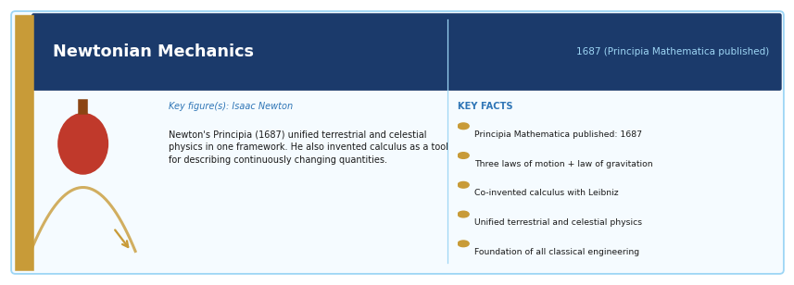
Period: 1687 (Principia Mathematica published) | Key figure(s): Isaac Newton
HISTORICAL CONTEXT
Isaac Newton's 'Philosophiae Naturalis Principia Mathematica' (1687) is widely regarded as the most important scientific book ever published. Working at Cambridge during the plague years (1665–66), Newton formulated his three laws of motion and the law of universal gravitation. He also independently co-invented calculus (simultaneously with Leibniz) as a mathematical tool for dealing with continuously changing quantities. The Principia unified terrestrial and celestial physics for the first time.
SCIENTIFIC / TECHNOLOGICAL SIGNIFICANCE
Newtonian mechanics provided a single coherent framework for understanding all motion — from falling apples to planetary orbits, from pendulums to projectiles. It is predictive, precise, and universal. For over 200 years it was the complete theory of the physical world. It remains the foundation of mechanical engineering, structural design, ballistics, orbital mechanics, and fluid dynamics.
IMPACT ON HUMANITY
Newtonian mechanics enabled the Industrial Revolution by providing the mathematical tools to design engines, structures, and machines. It underpinned the celestial mechanics needed to predict planetary positions, navigate at sea, and eventually design spacecraft trajectories. Though superseded by relativity and quantum mechanics at extreme scales, classical mechanics is still the basis of most engineering. Newton's framework is one of the greatest intellectual achievements of any individual.
MULTIMEDIA & FURTHER RESOURCES
▸ Newton's Principia Mathematica (Online, Cambridge Digital Library) — Cambridge
▸ BBC: Isaac Newton — The Last Magician (Documentary) — BBC
▸ Crash Course: Newton's Laws of Motion (YouTube) — YouTube
▸ The Royal Society: Newton's Papers Online — Royal Society

3. Industrial, Energy, and Transport Revolutions

Steam Engine
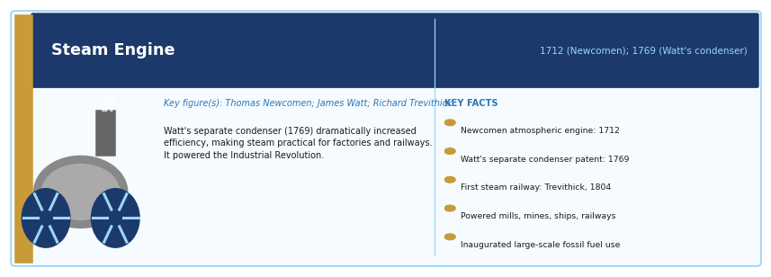
Period: 1712 (Newcomen atmospheric engine); 1769 (Watt's separate condenser patent) | Key figure(s): Thomas Newcomen; James Watt (improved design); Richard Trevithick (high-pressure steam)
HISTORICAL CONTEXT
Early steam engines were built by Thomas Savery (1698) and Thomas Newcomen (1712) to pump water from coal mines. James Watt's crucial improvement — the separate condenser (patented 1769) — dramatically increased efficiency, making steam practical for powering machinery. Watt's partnership with businessman Matthew Boulton commercialised the engine, and Richard Trevithick later developed high-pressure steam engines that made locomotives possible.
SCIENTIFIC / TECHNOLOGICAL SIGNIFICANCE
The steam engine was the prime mover of the Industrial Revolution. It converted thermal energy into mechanical work on a scale previously unimaginable, freeing production from dependence on wind, water, or muscle power. It powered textile mills, ironworks, mines, railways, and steam ships, and drove rapid urbanisation.
IMPACT ON HUMANITY
The Industrial Revolution, catalysed by the steam engine, transformed the global economy within a century. It was the proximate cause of a dramatic increase in living standards in industrialising nations, but also of child labour, urban poverty, air pollution, and — through colonialism — of the exploitation of much of the non-industrialised world. The steam engine also inaugurated humanity's large-scale consumption of fossil fuels, which remains the defining environmental challenge of the 21st century.
MULTIMEDIA & FURTHER RESOURCES
▸ Science Museum London: Steam Engine Collection — Science Museum
▸ Crash Course: The Industrial Revolution (YouTube) — YouTube
▸ PBS: Industrial Revolution — The Steam Engine — PBS

Electricity Generation and Distribution
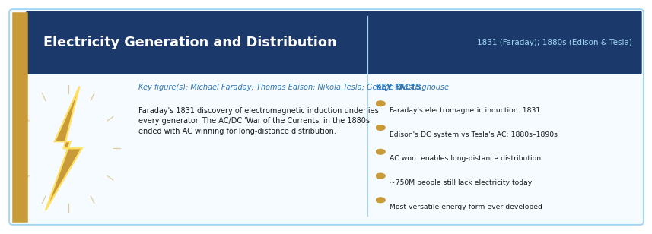
Period: 1831 (Faraday's electromagnetic induction); 1880s (Edison and Tesla's competing systems) | Key figure(s): Michael Faraday; Thomas Edison; Nikola Tesla; George Westinghouse
HISTORICAL CONTEXT
Michael Faraday discovered electromagnetic induction in 1831, demonstrating that moving a magnet through a coil of wire generates electrical current. This principle underlies every generator and dynamo. The great practical battle of the 1880s–1890s — the 'War of the Currents' — pitched Thomas Edison's DC system against Nikola Tesla's AC system (backed by Westinghouse). AC won, enabling long-distance electrical distribution.
SCIENTIFIC / TECHNOLOGICAL SIGNIFICANCE
Electrical power distribution is the infrastructure that underlies virtually all of modern life. It powers lighting, manufacturing, computing, refrigeration, medical equipment, communications, and transportation. Electricity is unique among energy forms in its versatility: it can be generated from almost any energy source and converted into almost any useful form (heat, light, mechanical work, computation).
IMPACT ON HUMANITY
Electrification transformed cities, homes, hospitals, and factories. In developing countries, access to electricity remains one of the most reliable predictors of improved health outcomes, economic productivity, and educational achievement. The IEA estimates that approximately 750 million people still lack access to electricity as of the mid-2020s — a measure of the challenge remaining.
MULTIMEDIA & FURTHER RESOURCES
▸ PBS: Nikola Tesla — Master of Lightning (Documentary) — PBS
▸ IEEE: History of the Electric Power Industry — IEEE Engineering History
▸ TED-Ed: How Does Electricity Work? (Animation) — YouTube

Electromagnetism
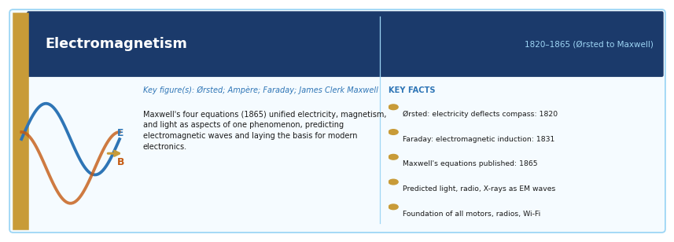
Period: 1820–1865 (Ørsted, Ampère, Faraday, Maxwell) | Key figure(s): Hans Christian Ørsted; André-Marie Ampère; Michael Faraday; James Clerk Maxwell
HISTORICAL CONTEXT
In 1820, Ørsted noticed that a magnetic needle was deflected by a nearby electrical current, revealing that electricity and magnetism are related phenomena. Ampère mathematised this relationship. Faraday showed that a changing magnetic field induces an electric current (1831). James Clerk Maxwell unified all these observations in his four equations of electromagnetism (1865), predicting the existence of electromagnetic waves — later confirmed as light, radio, X-rays, and all electromagnetic radiation.
SCIENTIFIC / TECHNOLOGICAL SIGNIFICANCE
Maxwell's equations are one of the greatest intellectual achievements in physics. They describe light, radio waves, microwaves, X-rays, and all other electromagnetic radiation as aspects of the same phenomenon. The equations directly led to Einstein's special theory of relativity, and they underpin radio, television, radar, wireless communication, fibre optics, and all of modern electronics.
IMPACT ON HUMANITY
Electromagnetism is the physical foundation of the modern technological world. Every electric motor (in everything from a washing machine to an electric car), every generator, every radio, every MRI scanner, every Wi-Fi transmission, every optical fibre — all operate on principles described by Faraday and Maxwell. Richard Feynman called Maxwell's equations 'the most significant event of the 19th century.'
MULTIMEDIA & FURTHER RESOURCES
▸ Khan Academy: Maxwell's Equations and Electromagnetism — Khan Academy
▸ PBS Space Time: Maxwell's Equations (YouTube) — YouTube
▸ The Royal Institution: Michael Faraday and the Electric Motor — Royal Institution

Internal Combustion Engine
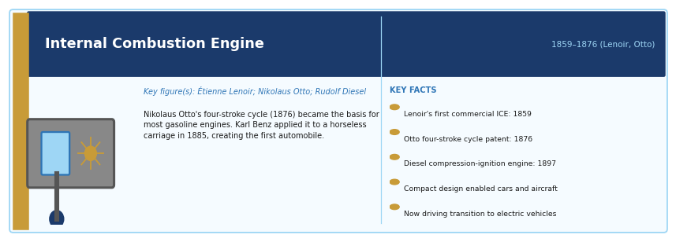
Period: 1859–1876 (first practical designs: Lenoir, Otto, Beau de Rochas) | Key figure(s): Étienne Lenoir; Nikolaus Otto (four-stroke cycle, 1876); Rudolf Diesel (1897)
HISTORICAL CONTEXT
Étienne Lenoir built the first commercially successful internal combustion engine in 1859, running on coal gas. Nikolaus Otto developed the four-stroke cycle in 1876, which became the basis for most gasoline engines. Karl Benz and Gottlieb Daimler applied the engine to horseless carriages in the 1880s, creating the automobile. Rudolf Diesel patented his compression-ignition engine in 1897.
SCIENTIFIC / TECHNOLOGICAL SIGNIFICANCE
The internal combustion engine (ICE) powered the automobile, the aeroplane, the motorcycle, the tractor, and the ship in the 20th century. It enabled mass personal mobility, agricultural mechanisation, and rapid military logistics. Unlike the steam engine, it was compact and relatively lightweight, enabling transport applications the steam engine could not practically serve.
IMPACT ON HUMANITY
The ICE reshaped cities (urban sprawl, highways, suburbs), agriculture (tractors replaced horses and oxen), warfare (motor vehicles, aircraft), and global trade (diesel ships). It also drove the 20th century's fossil fuel economy and is now a primary contributor to climate change, driving the transition to electric vehicles in the 21st century.
MULTIMEDIA & FURTHER RESOURCES
▸ How It Works: Internal Combustion Engine (Animated) — YouTube
▸ Science Museum: The Internal Combustion Engine — Science Museum

Automobile
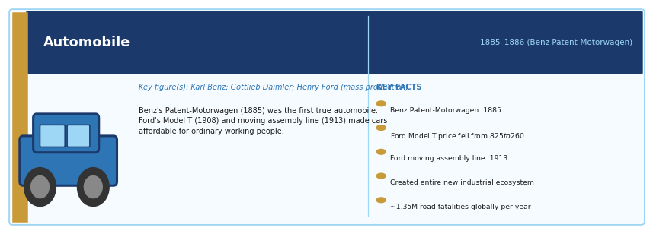
Period: 1885–1886 (Benz Patent-Motorwagen); mass production from 1908 (Ford Model T) | Key figure(s): Karl Benz; Gottlieb Daimler; Henry Ford (mass production)
HISTORICAL CONTEXT
Karl Benz's Patent-Motorwagen (1885) is generally regarded as the first true automobile. Gottlieb Daimler independently developed a similar vehicle in 1886. The transformation from a luxury novelty to a mass consumer product came with Henry Ford's moving assembly line (1913) and the Model T (from $825 in 1908 to $260 by 1925), which made cars affordable to working-class Americans.
SCIENTIFIC / TECHNOLOGICAL SIGNIFICANCE
The automobile created an entirely new industrial ecosystem: steel, rubber, glass, petroleum refining, road construction, urban planning, insurance, tourism, and logistics. It radically changed where people could live relative to where they worked, enabling suburbs. Ford's assembly line pioneered industrial mass production techniques adopted across all manufacturing.
IMPACT ON HUMANITY
The automobile is one of the most economically significant inventions in history and one of the most socially disruptive. It created immense wealth, enabled personal freedom of movement, and supported mid-20th century prosperity in industrialised nations. It also contributed to air pollution, climate change, road fatalities (approximately 1.35 million per year globally), urban sprawl, and dependence on imported oil.
MULTIMEDIA & FURTHER RESOURCES
▸ Henry Ford Museum: The Story of the Automobile — Henry Ford Museum
▸ Crash Course: The Automobile and Its Impact (YouTube) — YouTube

Airplane
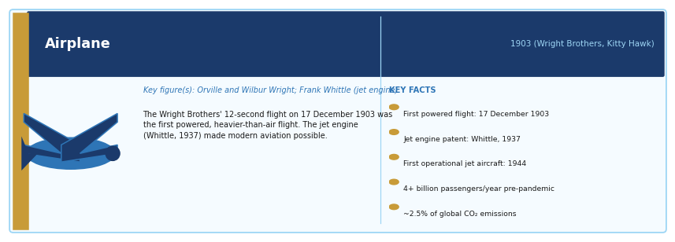
Period: 1903 (Wright Brothers' first powered flight, Kitty Hawk, North Carolina) | Key figure(s): Orville and Wilbur Wright; later: Louis Blériot, Anthony Fokker, Frank Whittle (jet engine)
HISTORICAL CONTEXT
Orville and Wilbur Wright's 12-second, 120-foot flight at Kitty Hawk on 17 December 1903 was the first powered, controlled, heavier-than-air flight. The Wright brothers succeeded through systematic aeronautical research, wind-tunnel testing, and the development of three-axis control. Within a decade, aircraft were being used in warfare (World War I). Commercial aviation began in the 1920s and was transformed by the jet engine (Frank Whittle, 1937 patent; first operational jet aircraft, 1944).
SCIENTIFIC / TECHNOLOGICAL SIGNIFICANCE
Aviation compressed the globe, making intercontinental travel routine rather than extraordinary. The jet age (post-1950) turned a journey that once took weeks by ship into a matter of hours. Aviation also transformed warfare (strategic bombing, parachute forces, air supply), international trade (air cargo), and emergency humanitarian response.
IMPACT ON HUMANITY
Commercial aviation now carries over 4 billion passengers per year (pre-pandemic peak) and is responsible for approximately 2.5% of global CO₂ emissions. It has created a truly global economy, enabling just-in-time supply chains for high-value goods, mass international tourism, and the migration of talent across borders. Aviation is both a symbol of modern freedom and a significant sustainability challenge.
MULTIMEDIA & FURTHER RESOURCES
▸ Smithsonian Air and Space Museum: Wright Brothers Collection — Smithsonian
▸ NASA: History of Aviation — NASA
▸ TED-Ed: How Planes Fly (Animation) — YouTube

Refrigeration
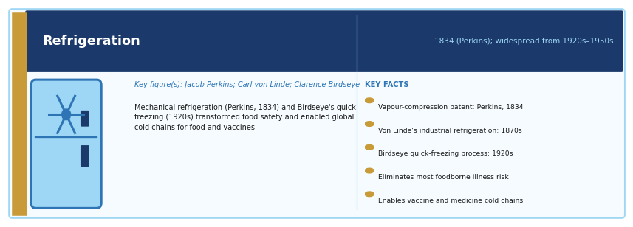
Period: 1834 (Perkins' vapour-compression cycle patent); widespread use from 1920s–1950s | Key figure(s): Jacob Perkins; Carl von Linde; Clarence Birdseye (commercial frozen food)
HISTORICAL CONTEXT
Mechanical refrigeration using vapour-compression was pioneered by Jacob Perkins in 1834. Carl von Linde developed efficient industrial refrigeration in the 1870s, enabling large-scale commercial ice production and cold storage. Domestic refrigerators replaced ice-boxes in most American homes between the 1920s and 1950s. Clarence Birdseye developed the quick-freezing process in the 1920s, making frozen food commercially practical.
SCIENTIFIC / TECHNOLOGICAL SIGNIFICANCE
Refrigeration is one of the most consequential public health technologies ever invented. It dramatically reduced food spoilage and foodborne illness, enabled safe long-distance food transport, made fresh produce available year-round, and preserved vaccines and medicines that require cold storage. Without refrigeration, the modern global food supply chain would be impossible.
IMPACT ON HUMANITY
Refrigeration has been described by some public health historians as responsible for more saved lives than any other single technology, by reducing food poisoning and enabling vaccine cold chains. It transformed diet in developed countries, enabled global meat trade, and made tropical food exports to temperate markets viable. Modern cold chains now underpin the delivery of COVID-19 and other vaccines to every part of the world.
MULTIMEDIA & FURTHER RESOURCES
▸ Smithsonian Magazine: The Invention of the Refrigerator — Smithsonian
▸ TED-Ed: How Refrigerators Work (Animation) — YouTube

4. Medicine, Biology, and Public Health

Vaccination
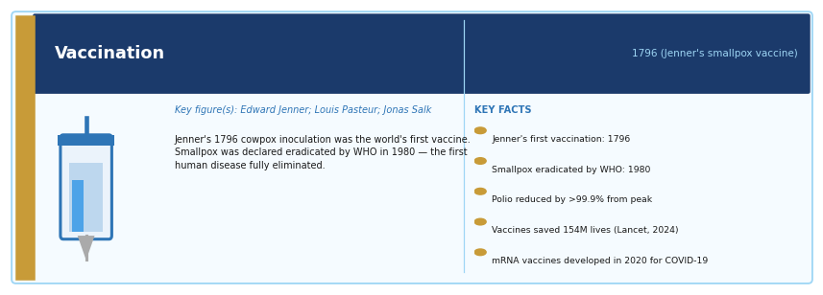
Period: 1796 (Jenner's smallpox vaccine); mass immunisation programmes from the 19th century | Key figure(s): Edward Jenner (smallpox); Louis Pasteur (rabies, cholera); Jonas Salk (polio)
HISTORICAL CONTEXT
Edward Jenner observed in 1796 that milkmaids who contracted cowpox seemed immune to smallpox. He tested vaccination by inoculating eight-year-old James Phipps with cowpox material and then exposing him to smallpox — the boy did not become ill. This was the world's first vaccine. Louis Pasteur developed vaccines for chicken cholera, anthrax, and rabies in the 1880s, and established the germ theory basis of vaccination.
SCIENTIFIC / TECHNOLOGICAL SIGNIFICANCE
Vaccination is the most cost-effective public health intervention ever developed. The WHO declared smallpox eradicated in 1980 — the first (and so far only) complete eradication of a human disease, saving an estimated 5 million lives per year. Polio has been reduced by over 99.9% from its peak. Measles, diphtheria, tetanus, hepatitis B, and many other once-deadly diseases are now preventable.
IMPACT ON HUMANITY
Vaccines have saved an estimated 154 million lives in the past 50 years (Lancet, 2024). The COVID-19 mRNA vaccines, developed in 2020 using decades of prior mRNA research, are estimated to have prevented millions of deaths within their first two years of deployment. Vaccination is one of the clearest examples of science directly extending human lifespan at population scale.
MULTIMEDIA & FURTHER RESOURCES
▸ WHO: History of Vaccination — WHO
▸ PBS: The Vaccine War (Documentary) — PBS Frontline
▸ Our World in Data: Vaccination Coverage and Disease Reduction — Our World in Data
▸ TED-Ed: How Vaccines Work (Animation) — YouTube

Antibiotics
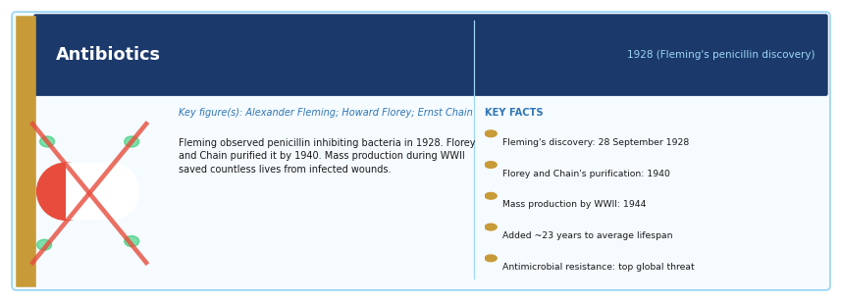
Period: 1928 (Fleming's penicillin discovery); 1940s (mass production and clinical use) | Key figure(s): Alexander Fleming (discovery, 1928); Howard Florey and Ernst Chain (development, 1940s)
HISTORICAL CONTEXT
Alexander Fleming discovered in 1928 that a mould, Penicillium notatum, was inhibiting bacterial growth on his petri dishes. He published his observation but could not purify penicillin to medical grade. Howard Florey and Ernst Chain at Oxford developed purification techniques in the early 1940s, enabling clinical trials. Mass production by US pharmaceutical companies during World War II made penicillin available in large quantities by 1944, saving countless military and civilian lives.
SCIENTIFIC / TECHNOLOGICAL SIGNIFICANCE
Antibiotics made bacterial infections — previously often fatal — reliably treatable. They enabled safe surgery (by controlling post-operative infection), organ transplantation (which requires immune suppression that leaves patients vulnerable to infection), cancer chemotherapy, premature infant survival, and childbirth safety. They are foundational to all of modern medicine.
IMPACT ON HUMANITY
Antibiotics are estimated to have added approximately 23 years to the average human lifespan in the 20th century (accounting for the reduction in infectious disease mortality). However, antibiotic resistance — caused by overuse and misuse — is now one of the most serious threats to global health. The WHO lists antimicrobial resistance as one of the top ten global public health threats facing humanity.
MULTIMEDIA & FURTHER RESOURCES
▸ Alexander Fleming: Discovery of Penicillin (Nobel Prize biography) — Nobel Prize
▸ BBC Documentary: Penicillin — The Wonder Drug — BBC
▸ WHO: Antimicrobial Resistance — Global Overview — WHO

Germ Theory of Disease
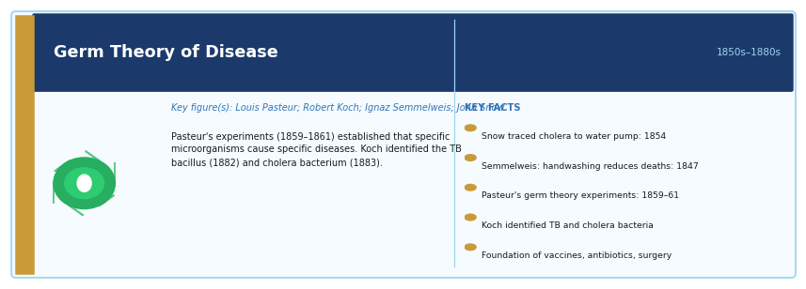
Period: 1850s–1880s (Pasteur and Koch's foundational work) | Key figure(s): Louis Pasteur; Robert Koch; Ignaz Semmelweis; John Snow
HISTORICAL CONTEXT
Before germ theory, disease was attributed to 'miasma' — bad air from rotting matter. John Snow's 1854 investigation of cholera in London's Soho district (tracing it to a contaminated water pump) provided early epidemiological evidence against miasma. Ignaz Semmelweis showed that hand-washing reduced childbed fever in Viennese hospitals (though he was dismissed). Louis Pasteur's germ theory experiments (1859–1861) and Robert Koch's identification of specific bacterial pathogens (tuberculosis, 1882; cholera, 1883) established the microbial basis of infectious disease.
SCIENTIFIC / TECHNOLOGICAL SIGNIFICANCE
Germ theory is the conceptual foundation of modern infectious disease medicine, surgery, food safety, and public health. Once it was established that specific microorganisms cause specific diseases, it became possible to develop vaccines and antibiotics, design effective sanitation systems, create sterile surgical technique, and build rational public health policy.
IMPACT ON HUMANITY
Germ theory transformed surgery (Lister's antiseptic technique dramatically reduced post-operative mortality), public health (sewage systems, clean water, food inspection), and medicine. The entire pharmaceutical industry, vaccine development pipeline, and global health surveillance system rest on germ theory. Without it, the COVID-19 pandemic response — sequencing the virus in days and developing vaccines in months — would have been inconceivable.
MULTIMEDIA & FURTHER RESOURCES
▸ CDC: History of Germ Theory and Public Health — CDC
▸ Crash Course: Germ Theory (YouTube) — YouTube
▸ John Snow Society: Cholera and the Birth of Epidemiology — John Snow Society

Anaesthesia
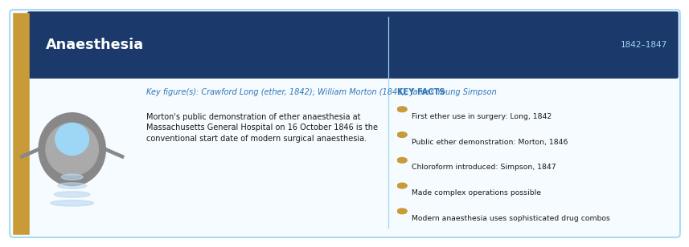
Period: 1842–1847 (Crawford Long, William Morton, James Young Simpson) | Key figure(s): Crawford Long (ether, 1842); William Morton (first public demonstration, 1846); James Young Simpson (chloroform)
HISTORICAL CONTEXT
Before anaesthesia, surgery was agonising and necessarily rapid. Surgeons were valued for speed. Crawford Long first used ether anaesthesia for a minor operation in 1842 but did not publish his work. William Morton's public demonstration of ether at Massachusetts General Hospital on 16 October 1846 is conventionally treated as the inauguration of surgical anaesthesia. James Young Simpson introduced chloroform the following year. Modern anaesthesia involves sophisticated combinations of drugs and monitoring.
SCIENTIFIC / TECHNOLOGICAL SIGNIFICANCE
Anaesthesia made it possible to perform long, complex operations without the patient suffering unbearable pain or struggling against the surgeon. It enabled thoracic, abdominal, neurological, and orthopaedic surgery. Without anaesthesia, organ transplantation, cardiac surgery, brain surgery, and complex trauma repair would be impossible.
IMPACT ON HUMANITY
Anaesthesia is one of the enabling technologies of all modern surgery. The development of general anaesthesia, combined with antiseptic technique and later antibiotics, transformed surgery from an emergency measure of last resort into a routine, relatively safe medical intervention. Modern anaesthesiologists now maintain patients through hours of cardiac surgery, organ transplantation, and complex reconstructive procedures that would have been unthinkable in 1845.
MULTIMEDIA & FURTHER RESOURCES
▸ Massachusetts General Hospital: The Ether Dome — History of Anaesthesia — MGH
▸ Wellcome Collection: The History of Anaesthesia — Wellcome Collection

X-Rays and Medical Imaging
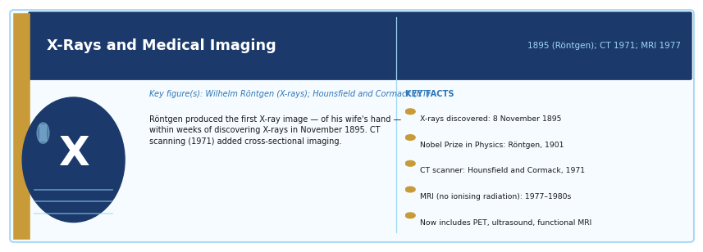
Period: 1895 (Röntgen's discovery of X-rays); CT (1971); MRI (1977); ultrasound (1950s) | Key figure(s): Wilhelm Conrad Röntgen (X-rays, 1895); Godfrey Hounsfield and Allan Cormack (CT, 1971)
HISTORICAL CONTEXT
Wilhelm Conrad Röntgen discovered X-rays on 8 November 1895 while experimenting with cathode ray tubes. He produced the first X-ray image — of his wife's hand — within weeks. The discovery won him the first Nobel Prize in Physics (1901). X-ray imaging was immediately adopted in medicine and surgery. CT scanning (computed tomography), developed by Hounsfield and Cormack in 1971, used X-rays to produce cross-sectional images. MRI (magnetic resonance imaging) followed in the 1970s–1980s, using radio waves and magnetic fields to image soft tissue without ionising radiation.
SCIENTIFIC / TECHNOLOGICAL SIGNIFICANCE
Medical imaging allows physicians to see inside the human body without surgery. This transformed diagnosis: fractured bones, tumours, cardiac defects, brain abnormalities, internal bleeding, and blocked arteries can now all be detected, precisely located, and monitored non-invasively. Modern imaging guided interventions (biopsies, catheter procedures) avoid many open operations.
IMPACT ON HUMANITY
Medical imaging has fundamentally changed clinical medicine. Cancer is now frequently detected at early, treatable stages through imaging screening. Cardiac imaging guides interventional procedures that restore blood flow without open surgery. Brain MRI is central to diagnosing stroke, multiple sclerosis, and dementia. Radiology and imaging together are now one of the largest and most technologically sophisticated specialties in medicine.
MULTIMEDIA & FURTHER RESOURCES
▸ Röntgen's Nobel Prize Lecture and Original X-ray Images — Nobel Prize
▸ NIBIB: How MRI Works (Video and Diagram) — NIBIB
▸ Radiopaedia: Medical Imaging Education Resources — Radiopaedia

Sanitation and Clean Water Systems
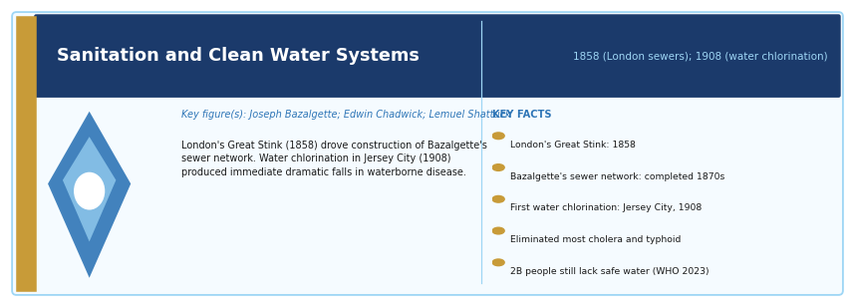
Period: 1850s–1900 (Great Stink, London sewer system); 20th century global expansion | Key figure(s): Joseph Bazalgette (London sewers); Edwin Chadwick; John Snow; Lemuel Shattuck
HISTORICAL CONTEXT
In 1858, the 'Great Stink' in London — caused by raw sewage in the Thames — prompted the construction of a revolutionary sewage network, designed by civil engineer Joseph Bazalgette. By the 1870s, London's system was largely complete, dramatically reducing cholera and typhoid. In the United States, the filtration and chlorination of drinking water supplies in the early 20th century (Jersey City, 1908) produced large, immediate reductions in waterborne disease mortality.
SCIENTIFIC / TECHNOLOGICAL SIGNIFICANCE
Clean water and sanitation are arguably the single most important public health infrastructure ever built. Waterborne diseases — cholera, typhoid, dysentery — killed tens of millions in 19th-century cities. The engineering of sewage systems and water treatment eliminated the vast majority of these deaths in developed nations within decades.
IMPACT ON HUMANITY
The McKinsey Global Institute and Harvard School of Public Health have both identified clean water access as the public health intervention with the highest return on investment in history. Globally, approximately 2 billion people still lack access to safely managed drinking water, and 3.6 billion lack safe sanitation (WHO/UNICEF, 2023). The burden of waterborne disease falls overwhelmingly on low-income countries.
MULTIMEDIA & FURTHER RESOURCES
▸ Our World in Data: Water Access and Sanitation — Our World in Data
▸ Thames Water: History of London's Sewers — Thames Water
▸ CDC: A Century of US Water Chlorination (Public Health Report) — CDC

DNA Structure and Molecular Genetics
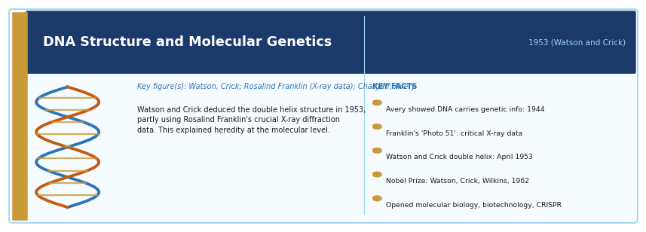
Period: 1953 (Watson and Crick's double helix structure); preceded by Avery (1944) and Franklin's X-ray work | Key figure(s): James Watson, Francis Crick; Rosalind Franklin (X-ray crystallography); Erwin Chargaff; Oswald Avery
HISTORICAL CONTEXT
Oswald Avery showed in 1944 that DNA — not protein — is the carrier of genetic information. Erwin Chargaff established that adenine pairs with thymine and cytosine pairs with guanine. Rosalind Franklin's X-ray crystallography images — especially 'Photo 51' — provided crucial structural data. Watson and Crick used all this information (including Franklin's data, controversially accessed without her knowledge) to deduce the double helix structure of DNA in 1953. The discovery explained how genetic information is stored and copied.
SCIENTIFIC / TECHNOLOGICAL SIGNIFICANCE
The double helix is the molecular key to heredity, evolution, and life itself. DNA's structure immediately suggested a mechanism for replication (each strand serves as a template for a new strand). It opened the era of molecular biology: the understanding of gene expression, protein synthesis, genetic mutation, cancer biology, viral replication, and evolution at the molecular level all flowed from the 1953 discovery.
IMPACT ON HUMANITY
Molecular genetics has transformed medicine, forensics, agriculture, and evolutionary biology. Genetic testing can now identify susceptibility to hereditary diseases. DNA fingerprinting has transformed criminal justice. Recombinant DNA technology produces insulin, growth hormone, and dozens of other drugs. Gene therapy is beginning to cure genetic diseases. The CRISPR gene-editing technology (see entry below) is a direct descendant of this discovery.
MULTIMEDIA & FURTHER RESOURCES
▸ Wellcome Trust: The Double Helix — Annotated Original Paper — Nature (1953)
▸ DNA from the Beginning (Animated tutorials on genetics) — CSHL
▸ BBC Documentary: Life Story (Crick and Watson) — BBC
▸ Nobel Prize: Watson and Crick — DNA Structure — Nobel Prize

Human Genome Sequencing
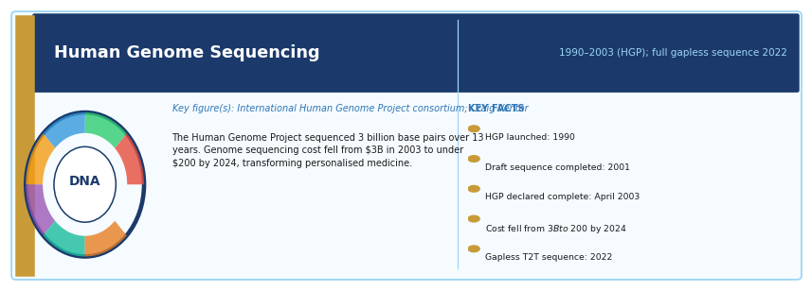
Period: 1990–2003 (Human Genome Project); first complete sequence 2022 | Key figure(s): Human Genome Project consortium (NIH, Wellcome Trust, multiple nations); Craig Venter (Celera Genomics)
HISTORICAL CONTEXT
The Human Genome Project (HGP), launched in 1990 and declared complete in 2003, was a 13-year international collaboration to sequence all 3 billion base pairs of human DNA. It was done in parallel by public consortia and Craig Venter's private company Celera Genomics, whose competition accelerated the timeline. A truly complete (gapless) sequence was published only in 2022 by the Telomere-to-Telomere consortium.
SCIENTIFIC / TECHNOLOGICAL SIGNIFICANCE
The human genome sequence is a complete parts list of human biology. It has transformed the understanding of genetic disease, cancer, human evolution, and population genetics. It enabled genome-wide association studies (GWAS) that identify genetic variants linked to disease susceptibility. It established that humans share approximately 99.9% of their genome with one another and about 96% with chimpanzees.
IMPACT ON HUMANITY
The HGP catalysed the genomics industry. The cost of sequencing a human genome fell from $3 billion in 2003 to under $200 by 2024, enabling clinical genome sequencing, personalised cancer treatment, newborn genetic screening, non-invasive prenatal testing, and drug discovery. Genomic data is now central to understanding COVID-19 variants, rare genetic diseases, and inherited cancer risk.
MULTIMEDIA & FURTHER RESOURCES
▸ NHGRI: Human Genome Project Reference — NIH/NHGRI
▸ Nature: Original HGP Publication (2001) — Nature
▸ PBS Nova: Cracking the Code of Life (Documentary) — PBS

CRISPR Gene Editing
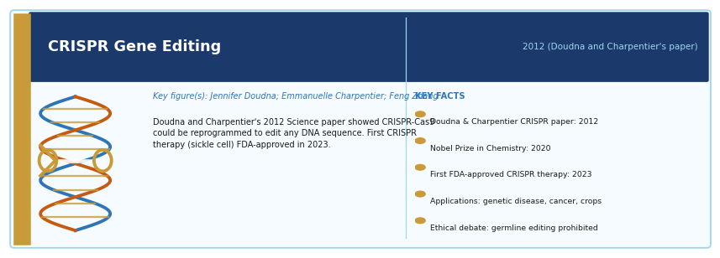
Period: 2012 (CRISPR-Cas9 adapted for gene editing); first clinical applications from 2020s | Key figure(s): Jennifer Doudna and Emmanuelle Charpentier (Nobel Prize 2020); Feng Zhang (independent parallel work)
HISTORICAL CONTEXT
CRISPR (Clustered Regularly Interspaced Short Palindromic Repeats) was first identified as a bacterial immune system. Jennifer Doudna and Emmanuelle Charpentier, in a 2012 paper in Science, showed that the CRISPR-Cas9 system could be reprogrammed to edit any DNA sequence with unprecedented precision and ease. Feng Zhang at the Broad Institute adapted it for use in eukaryotic cells (including human cells) the following year. In 2023, the FDA approved the first CRISPR-based therapy for sickle cell disease.
SCIENTIFIC / TECHNOLOGICAL SIGNIFICANCE
CRISPR allows scientists to cut DNA at any specified location and insert, delete, or modify genetic sequences. It is faster, cheaper, and more precise than previous gene-editing methods. It has potential applications in treating single-gene disorders (sickle cell disease, beta-thalassaemia, Huntington's disease), cancers, viral diseases (including HIV), and in developing disease-resistant crops.
IMPACT ON HUMANITY
CRISPR is transforming biomedical research and beginning to transform medicine. The first approved CRISPR therapies for sickle cell disease and beta-thalassaemia (2023) offer potentially curative one-time treatments. Agricultural applications could increase crop yields and disease resistance. CRISPR also raises profound ethical questions about germline editing (changes that would be inherited by future generations), which is currently prohibited in most countries.
MULTIMEDIA & FURTHER RESOURCES
▸ Nobel Prize: Doudna and Charpentier — CRISPR (2020) — Nobel Prize
▸ Innovative Genomics Institute: CRISPR Explained (Videos) — IGI
▸ Nature: CRISPR Timeline and Key Papers — Nature
▸ TED Talk: Jennifer Doudna — How CRISPR Lets Us Edit Our DNA — TED

5. Physics, Chemistry, and Materials Science

The Periodic Table
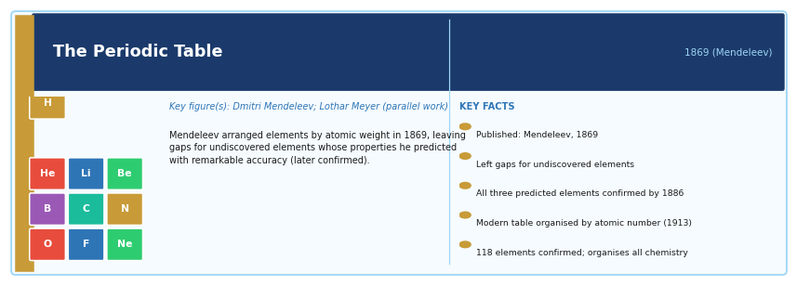
Period: 1869 (Mendeleev's publication); completed across the 20th century | Key figure(s): Dmitri Mendeleev; Lothar Meyer (independent parallel work)
HISTORICAL CONTEXT
In 1869, Dmitri Mendeleev arranged the 63 then-known elements by atomic weight and observed that their properties repeated periodically. Crucially, he left gaps for elements not yet discovered and predicted their properties with remarkable accuracy (gallium, scandium, and germanium were all subsequently discovered and matched his predictions). The modern periodic table, organised by atomic number after Moseley (1913), now contains 118 confirmed elements.
SCIENTIFIC / TECHNOLOGICAL SIGNIFICANCE
The periodic table is the foundational organising framework of chemistry. It reveals the underlying structure of matter: that all substances are made of atoms, each with a specific number of protons; that the electron arrangement of atoms determines their chemical behaviour; and that properties recur systematically across the table. It enables prediction of chemical reactivity, bonding behaviour, and the properties of compounds.
IMPACT ON HUMANITY
Every drug, material, alloy, semiconductor, and chemical product is designed using knowledge of the periodic table. It organises all of chemistry, geology, nuclear physics, materials science, and biochemistry. The development of the semiconductor industry — and thus all modern electronics — relied fundamentally on understanding silicon and neighbouring elements in the periodic table.
MULTIMEDIA & FURTHER RESOURCES
▸ Royal Society of Chemistry: Interactive Periodic Table — RSC
▸ IUPAC: Official Periodic Table — IUPAC
▸ TED-Ed: The History of the Periodic Table (Animation) — YouTube

Quantum Mechanics
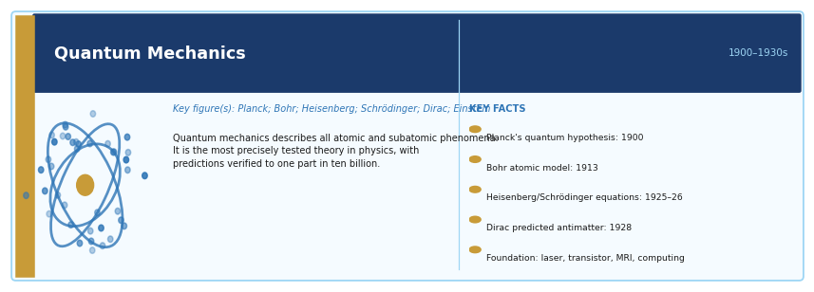
Period: 1900–1930s (Planck, Einstein, Bohr, Heisenberg, Schrödinger, Dirac) | Key figure(s): Max Planck; Niels Bohr; Werner Heisenberg; Erwin Schrödinger; Paul Dirac; Albert Einstein
HISTORICAL CONTEXT
Quantum mechanics emerged from attempts to explain phenomena that classical physics could not: blackbody radiation (Planck, 1900), the photoelectric effect (Einstein, 1905), and atomic spectra (Bohr, 1913). Heisenberg's matrix mechanics and Schrödinger's wave equation (both 1925–1926) provided mathematical frameworks. Dirac unified quantum mechanics with special relativity and predicted antimatter. The Copenhagen interpretation (Bohr, Heisenberg) remains the dominant framework, though alternatives continue to be debated.
SCIENTIFIC / TECHNOLOGICAL SIGNIFICANCE
Quantum mechanics is the most precisely tested scientific theory in history — its predictions agree with experiment to one part in ten billion in some cases. It describes all atomic and subatomic phenomena, all chemical bonding, all light-matter interactions, and all semiconductor behaviour. It is the theoretical foundation of the laser, the transistor, MRI, nuclear energy, LED lighting, and quantum computing.
IMPACT ON HUMANITY
Every semiconductor device — and thus every computer, smartphone, and electronic system — works because of quantum mechanical effects in materials. Lasers, which depend on quantum optics, are essential in medicine, communication, manufacturing, and data storage. MRI uses nuclear magnetic resonance, a quantum effect. Quantum computing, currently emerging, could revolutionise drug discovery, materials design, and cryptography.
MULTIMEDIA & FURTHER RESOURCES
▸ PBS Space Time: Quantum Mechanics Explained (YouTube series) — YouTube
▸ Feynman Lectures on Physics (Free Online, Caltech) — Caltech
▸ Nobel Prize: Quantum Mechanics History — Nobel Prize

Theory of Relativity
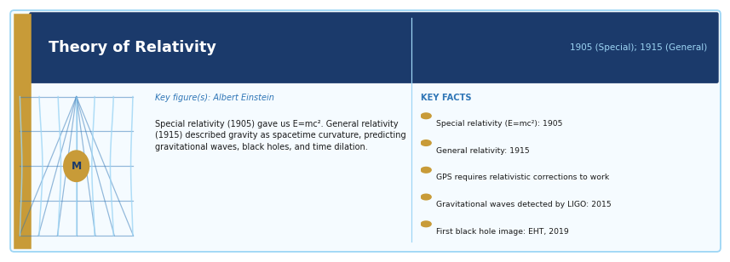
Period: 1905 (Special Relativity); 1915 (General Relativity) | Key figure(s): Albert Einstein
HISTORICAL CONTEXT
Albert Einstein published his Special Theory of Relativity in 1905 — his annus mirabilis year, in which he also explained the photoelectric effect and Brownian motion. Special relativity showed that the laws of physics are the same for all observers in uniform motion, and that the speed of light is constant for all observers — leading to the famous equation E=mc². His General Theory of Relativity (1915) extended this to accelerating reference frames and described gravity not as a force but as the curvature of spacetime caused by mass.
SCIENTIFIC / TECHNOLOGICAL SIGNIFICANCE
General relativity is the foundation of modern cosmology. It predicted gravitational waves (first detected in 2015), black holes (first imaged in 2019), the expansion of the universe, gravitational lensing, and time dilation. GPS satellites must account for relativistic effects (both special and general) or their position errors would accumulate by several kilometres per day. E=mc² underpins nuclear energy and nuclear medicine.
IMPACT ON HUMANITY
Relativity has practical consequences in every GPS device (which corrects for relativistic time dilation to provide accurate navigation), in nuclear energy (which releases energy described by E=mc²), in particle accelerators (which routinely accelerate particles to near-light-speed and observe relativistic effects), and in astrophysics. The detection of gravitational waves by LIGO in 2015 opened an entirely new observational window on the universe.
MULTIMEDIA & FURTHER RESOURCES
▸ Einstein Archive Online: Original Papers — Einstein Archive
▸ PBS Space Time: General Relativity Explained (YouTube) — YouTube
▸ LIGO: Gravitational Waves — First Detection (Video and Data) — LIGO/Caltech
▸ Event Horizon Telescope: First Black Hole Image (2019) — EHT

Nuclear Energy and Nuclear Science
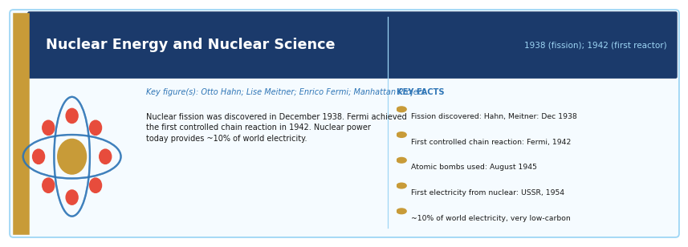
Period: 1938 (nuclear fission discovered); 1942 (first controlled chain reaction); 1951 (first electricity from nuclear power) | Key figure(s): Otto Hahn, Lise Meitner, Fritz Strassmann (fission); Enrico Fermi (reactor); Manhattan Project team
HISTORICAL CONTEXT
Otto Hahn and Fritz Strassmann discovered nuclear fission in December 1938, and Lise Meitner and Otto Frisch provided the theoretical explanation. In December 1942, Enrico Fermi's team achieved the first controlled nuclear chain reaction in Chicago Pile-1. The Manhattan Project (1942–45) used this knowledge to build the first atomic bombs, used against Hiroshima and Nagasaki in August 1945. The first electricity-generating nuclear reactor came online in the USSR in 1954.
SCIENTIFIC / TECHNOLOGICAL SIGNIFICANCE
Nuclear science revealed a new dimension of physical reality — that the nucleus of atoms contains enormous energy, accessible through fission and fusion. Nuclear power produces electricity with very low greenhouse gas emissions per kilowatt-hour. Nuclear medicine uses radioisotopes for cancer diagnosis (PET scanning) and treatment (radiotherapy). Atomic clocks based on nuclear resonance provide the timekeeping standard for GPS and internet synchronisation.
IMPACT ON HUMANITY
Nuclear energy produces about 10% of world electricity with very low lifecycle carbon emissions. It also produced nuclear weapons, which defined Cold War geopolitics and remain an existential threat. Nuclear medicine has saved millions of lives through radiotherapy and diagnostic imaging. The challenge of nuclear waste storage and the risk of weapons proliferation remain among the most consequential unresolved issues in science policy.
MULTIMEDIA & FURTHER RESOURCES
▸ IAEA: Nuclear Energy and Climate Change — IAEA
▸ Atomic Archive: History of Nuclear Science — Atomic Archive
▸ PBS American Experience: The Bomb (Documentary) — PBS

Plastics and Synthetic Materials
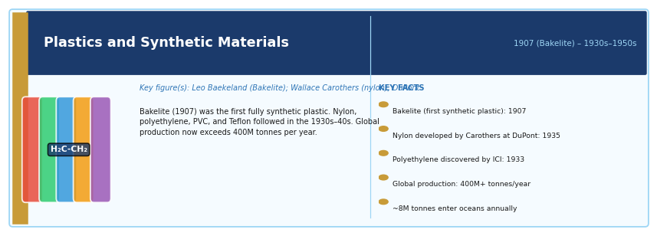
Period: 1907 (Bakelite, first fully synthetic plastic); 1930s–1950s (nylon, polyethylene, Teflon) | Key figure(s): Leo Baekeland (Bakelite); Wallace Carothers (nylon); DuPont chemists
HISTORICAL CONTEXT
Leo Baekeland invented Bakelite in 1907 — the first fully synthetic plastic, made from phenol and formaldehyde. Nylon was developed by Wallace Carothers at DuPont in the 1930s. Polyethylene was accidentally discovered by ICI chemists in 1933. PVC, polystyrene, Perspex, and Teflon all emerged in the 1930s–1940s. By the 1950s, cheap mass-produced plastics were transforming packaging, electronics, medicine, textiles, construction, and transport.
SCIENTIFIC / TECHNOLOGICAL SIGNIFICANCE
Plastics are lightweight, cheap, durable, chemically resistant, and formable into almost any shape. They replaced wood, metal, glass, and rubber in countless applications, reducing costs and enabling new products. Medical plastics (syringes, IV bags, blood tubing, implants) are essential to healthcare. Electronic insulation, food packaging, vehicle components, and textiles all depend on synthetic polymers.
IMPACT ON HUMANITY
Global plastic production exceeds 400 million tonnes per year. Plastics have enabled significant improvements in food safety, medical care, and affordability of consumer goods. They have also created one of the most serious environmental crises in history: plastic pollution in oceans, rivers, and soil; microplastics found in human blood, breast milk, and lung tissue; and an estimated 8 million tonnes of plastic entering the ocean each year.
MULTIMEDIA & FURTHER RESOURCES
▸ Our World in Data: Plastic Pollution — Our World in Data
▸ Science History Institute: The History of Plastics — Science History Institute
▸ BBC: Attenborough — A Life on Our Planet (Ocean plastics segment) — BBC

Fertilisers and Modern Agricultural Chemistry
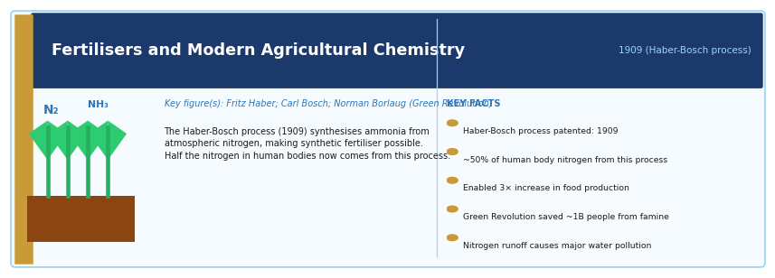
Period: 1909 (Haber-Bosch process for synthetic ammonia); widespread use from 1950s Green Revolution | Key figure(s): Fritz Haber; Carl Bosch (BASF); Norman Borlaug (Green Revolution)
HISTORICAL CONTEXT
The Haber-Bosch process (1909), which synthesises ammonia from atmospheric nitrogen and hydrogen, made synthetic nitrogen fertiliser possible at industrial scale. Before it, agriculture was limited by the availability of naturally occurring nitrogen (from guano, manure, and legumes). Norman Borlaug's Green Revolution (1950s–1970s) combined synthetic fertilisers with high-yield crop varieties to dramatically increase food production in developing countries.
SCIENTIFIC / TECHNOLOGICAL SIGNIFICANCE
The Haber-Bosch process has been described as the most important chemical reaction in history. It is estimated that approximately half of the nitrogen in the human body — in proteins, DNA, and amino acids — originates from synthetic ammonia made by this process. Without synthetic fertilisers, the current world population could not be fed.
IMPACT ON HUMANITY
Synthetic fertilisers enabled global food production to increase threefold in the 20th century while using only roughly 30% more agricultural land. The Green Revolution alone is estimated to have saved over a billion people from starvation. However, nitrogen fertiliser overuse causes eutrophication of water bodies (dead zones), nitrous oxide greenhouse gas emissions, and soil degradation — major environmental problems that sustainable agriculture must address.
MULTIMEDIA & FURTHER RESOURCES
▸ Our World in Data: How the World Produces Food — Our World in Data
▸ Royal Society of Chemistry: The Haber Process — RSC
▸ PBS: The Green Revolution and Norman Borlaug — PBS

6. Digital, Space, and Communication Technologies

Telegraph
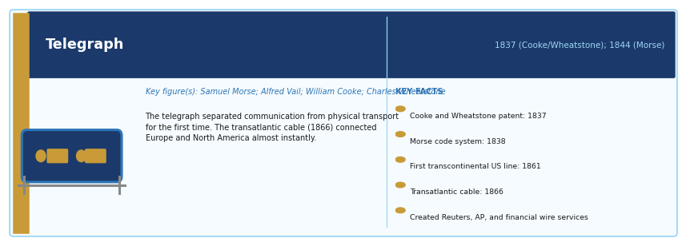
Period: 1837 (Cooke and Wheatstone, UK); 1844 (Morse's Baltimore–Washington line) | Key figure(s): Samuel Morse; Alfred Vail; William Cooke; Charles Wheatstone
HISTORICAL CONTEXT
The electromagnetic telegraph was developed simultaneously and independently in Britain (Cooke and Wheatstone, 1837) and the United States (Morse, Vail, 1838). The Morse system — encoding letters as dots and dashes — became the dominant standard. The first intercontinental telegraph cable (transatlantic) was successfully laid in 1866 by Isambard Kingdom Brunel's steamship SS Great Eastern, connecting Europe and North America.
SCIENTIFIC / TECHNOLOGICAL SIGNIFICANCE
The telegraph was the first technology to separate communication from physical transport. Before it, the fastest message was only as fast as the fastest horse or ship. The telegraph allowed near-instant communication across continents, transforming journalism (news agencies like Reuters and AP were born to exploit it), diplomacy, military command, financial markets, and railway coordination.
IMPACT ON HUMANITY
The telegraph created the world's first global information network and established the business and technical models — wired networks, message encoding, relay stations — that underpinned all subsequent telecommunication. Victorian commentators recognised it as revolutionary: the 1858 transatlantic cable was celebrated as the 'Victorian internet'. The telegraph is the direct ancestor of the telephone, radio, and internet.
MULTIMEDIA & FURTHER RESOURCES
▸ Smithsonian: The History of the Telegraph — Smithsonian
▸ Tom Standage: 'The Victorian Internet' — Overview — Wired

Telephone
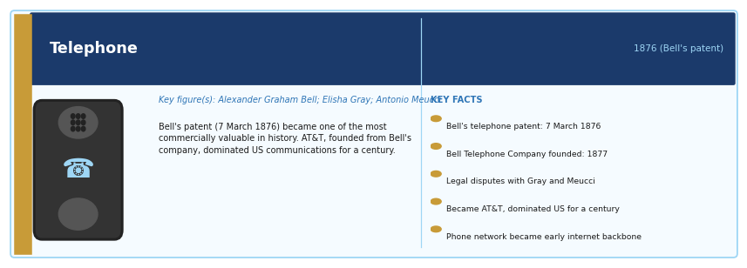
Period: 1876 (Bell's patent); widespread adoption from 1890s–1920s | Key figure(s): Alexander Graham Bell; Elisha Gray (disputed co-inventor); Antonio Meucci
HISTORICAL CONTEXT
Alexander Graham Bell was awarded the patent for the telephone on 7 March 1876 — one of the most commercially valuable patents in history. Elisha Gray filed a caveat on the same day, leading to prolonged legal disputes. Antonio Meucci had demonstrated a voice communication device in the 1850s but lacked funds to maintain his patent caveat. Bell's Telephone Company, founded in 1877, grew into AT&T, which dominated US communications for a century.
SCIENTIFIC / TECHNOLOGICAL SIGNIFICANCE
The telephone transformed personal, commercial, and governmental communication by enabling real-time two-way voice communication over distance. It was the dominant communication technology of the 20th century before being superseded — or rather absorbed — by digital networks and smartphones. The telephone network became the physical infrastructure for early internet dial-up connections.
IMPACT ON HUMANITY
The global telephone network at its peak connected billions of people through a circuit-switched system of unparalleled complexity. The principles established by early telephony — switching, multiplexing, signal encoding, network management — were foundational to all modern digital communication systems, including the internet. The mobile phone (see Smartphone entry) is a direct descendant.
MULTIMEDIA & FURTHER RESOURCES
▸ Library of Congress: Telephone and Alexander Graham Bell — Library of Congress
▸ IEEE: History of the Telephone — IEEE

Radio
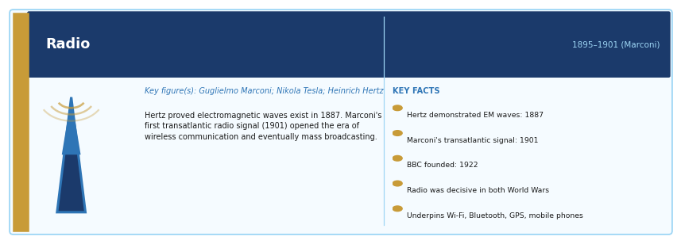
Period: 1895–1901 (Marconi's wireless telegraphy); broadcasting from 1920s | Key figure(s): Guglielmo Marconi; Nikola Tesla; Heinrich Hertz (discovery of radio waves, 1887)
HISTORICAL CONTEXT
Heinrich Hertz demonstrated electromagnetic waves (later called radio waves) in 1887, confirming Maxwell's theory. Guglielmo Marconi combined available components into a practical wireless telegraphy system, transmitting the first transatlantic radio signal in 1901 (Morse code, Cornwall to Newfoundland). Nikola Tesla held earlier patents on radio principles. Broadcasting — transmitting voice and music to mass audiences — began in the 1920s, with the BBC founded in 1922.
SCIENTIFIC / TECHNOLOGICAL SIGNIFICANCE
Radio was the first wireless communication technology, enabling communication without physical cables. It transformed maritime safety (the Titanic disaster of 1912 highlighted both its potential and its limitations in emergency communication). Military radio communication was decisive in both World Wars. Radio broadcasting created mass media culture — the first technology capable of addressing an audience of millions simultaneously.
IMPACT ON HUMANITY
Radio remains one of the world's most widely distributed communication technologies. FM radio, AM radio, shortwave, satellite radio, and digital radio (DAB) together reach billions of listeners. More broadly, radio-frequency technology underpins mobile phones, Wi-Fi, Bluetooth, GPS, radar, weather satellites, and radio astronomy. The concept of spectrum allocation and licensing, developed for radio, governs all wireless communication today.
MULTIMEDIA & FURTHER RESOURCES
▸ BBC: The History of Radio Broadcasting — BBC
▸ Marconi Society: History of Radio — Marconi Society

Transistor
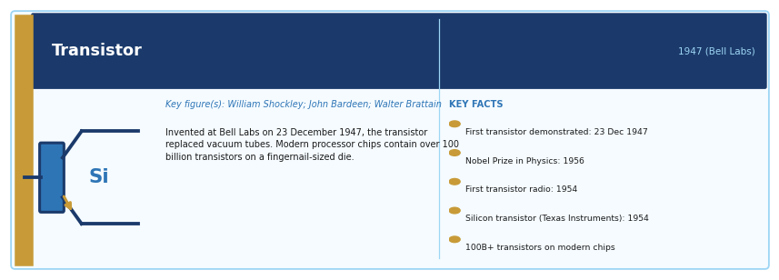
Period: 1947 (invention at Bell Labs); widespread commercial use from mid-1950s | Key figure(s): William Shockley, John Bardeen, Walter Brattain (Bell Labs)
HISTORICAL CONTEXT
The transistor was invented on 23 December 1947 by William Shockley, John Bardeen, and Walter Brattain at Bell Laboratories. It replaced the vacuum tube as the basic electronic switching and amplification device. The first commercially significant transistor radios appeared in 1954. The Nobel Prize in Physics was awarded to the inventors in 1956. The silicon transistor (Texas Instruments, 1954) established silicon as the dominant semiconductor material.
SCIENTIFIC / TECHNOLOGICAL SIGNIFICANCE
The transistor is the fundamental building block of all modern electronics. Every computer, smartphone, server, satellite, medical device, and digital system is built from transistors — binary switches that are either on (1) or off (0). A modern processor chip contains tens of billions of transistors on a piece of silicon the size of a fingernail. Without the transistor, digital computing as we know it is impossible.
IMPACT ON HUMANITY
The transistor enabled the miniaturisation and cost reduction of electronics predicted by Moore's Law: the number of transistors on a chip has doubled approximately every two years for 60 years, from 2,300 (Intel 4004, 1971) to over 100 billion (Apple M3 Ultra, 2024). This exponential improvement is the engine of the digital revolution — reducing the cost of computing by roughly a factor of a trillion since 1960.
MULTIMEDIA & FURTHER RESOURCES
▸ Computer History Museum: The Transistor — A Timeline — CHM
▸ Bell Labs: The Invention of the Transistor (Archive) — Bell Labs
▸ TED-Ed: The Transistor — How It Works (Animation) — YouTube

Integrated Circuit / Microchip
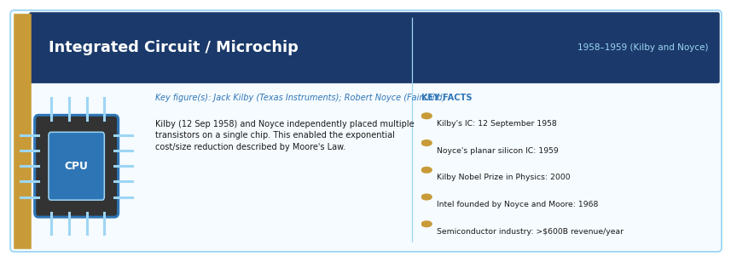
Period: 1958–1959 (independent inventions by Kilby and Noyce) | Key figure(s): Jack Kilby (Texas Instruments); Robert Noyce (Fairchild Semiconductor)
HISTORICAL CONTEXT
Jack Kilby demonstrated the first working integrated circuit at Texas Instruments on 12 September 1958, connecting multiple transistors on a single germanium wafer. Robert Noyce at Fairchild Semiconductor independently developed a superior version using silicon and a planar process in 1959. Noyce and Gordon Moore subsequently founded Intel (1968). Kilby received the Nobel Prize in Physics in 2000; Noyce had died in 1990.
SCIENTIFIC / TECHNOLOGICAL SIGNIFICANCE
The integrated circuit — placing multiple transistors and their connections on a single semiconductor chip — enabled the miniaturisation and cost reduction of electronics that has driven the digital age. The progression from first ICs with a handful of components to processors with 100+ billion transistors represents the most rapid and sustained improvement in the performance of any technology in history.
IMPACT ON HUMANITY
The microchip is the physical substrate of the digital world. Personal computers, smartphones, servers, GPS devices, medical implants, cars, aeroplanes, and household appliances all contain microchips. The semiconductor industry is now among the world's most economically and geopolitically significant, with Taiwan (TSMC), South Korea (Samsung), the United States (Intel, Qualcomm), and the Netherlands (ASML) at its centre.
MULTIMEDIA & FURTHER RESOURCES
▸ Computer History Museum: The Microchip — CHM
▸ Nobel Prize: Jack Kilby — Physics 2000 — Nobel Prize
▸ IEEE Spectrum: Inside the Chip — IEEE Spectrum

Computer
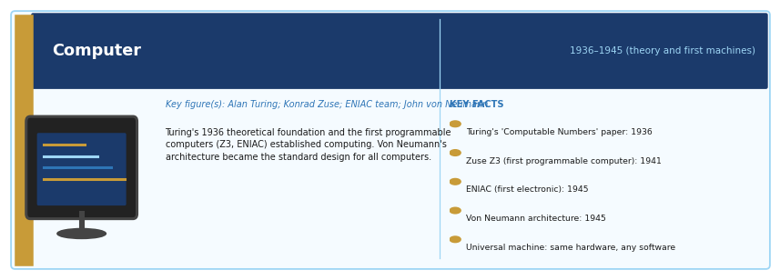
Period: 1936–1945 (theoretical foundations and first digital computers); commercial era from 1950s | Key figure(s): Alan Turing (theoretical foundation); Konrad Zuse (Z3, 1941); ENIAC team (1945); John von Neumann
HISTORICAL CONTEXT
Alan Turing's 1936 paper 'On Computable Numbers' defined the theoretical basis of computation — the Turing machine. Konrad Zuse's Z3 (1941) was the first programmable, fully automatic digital computer. ENIAC (Electronic Numerical Integrator and Computer, 1945) was the first general-purpose electronic digital computer. John von Neumann's architecture — separate memory for data and instructions — became the standard design for computers. Commercial computers appeared in the 1950s (UNIVAC, IBM 700 series).
SCIENTIFIC / TECHNOLOGICAL SIGNIFICANCE
The computer is a universal machine: it can simulate any other machine given sufficient time and memory. This universality means that the same physical device can serve as a word processor, a scientific calculator, a music player, a telephone, a navigation system, or an AI. The computer is the definitive amplifier of human cognitive capacity.
IMPACT ON HUMANITY
Computers transformed science (enabling simulations of climate, molecular biology, astrophysics), business (automating accounting, supply chains, financial markets), government (tax systems, social security, military), medicine (genomics, drug discovery, medical imaging analysis), and everyday life (communication, entertainment, navigation). The economic value generated by computing is immeasurable — the internet economy alone represents tens of trillions of dollars of activity annually.
MULTIMEDIA & FURTHER RESOURCES
▸ Computer History Museum: History of Computing — CHM
▸ BBC Documentary: Calculating Ada — The Countess of Computing — BBC
▸ Alan Turing Institute: Turing's Legacy — Turing Institute
▸ Crash Course: Computer Science (YouTube series) — YouTube

Internet
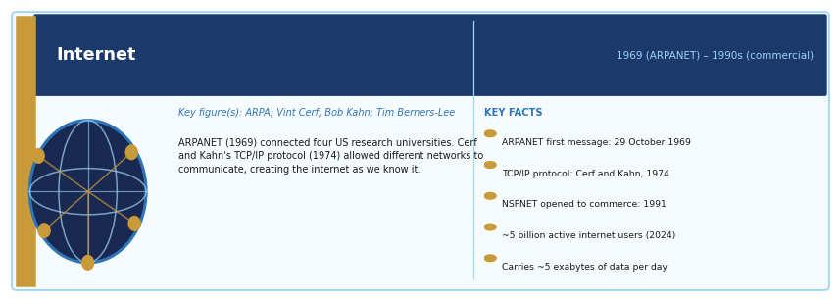
Period: 1969 (ARPANET); 1970s–1980s (TCP/IP protocols); 1990s (commercial internet) | Key figure(s): ARPA/DARPA team; Vint Cerf and Bob Kahn (TCP/IP, 1974); Tim Berners-Lee (WWW, 1989–1991)
HISTORICAL CONTEXT
The internet grew from ARPANET, a US Department of Defense project launched in 1969 to connect research computers. The critical innovation was the TCP/IP protocol suite developed by Vint Cerf and Bob Kahn (1974), which allowed different computer networks to communicate with each other — the defining characteristic of the internet. The National Science Foundation's NSFNET (1986) extended academic access. Commercial internet service providers emerged in the early 1990s. Tim Berners-Lee's World Wide Web (1991) made the internet accessible to general users.
SCIENTIFIC / TECHNOLOGICAL SIGNIFICANCE
The internet is the most significant communication infrastructure in human history. It is a global network of networks, connecting billions of devices, carrying an estimated 5 exabytes of data per day. It is not owned by any single entity — it is a commons governed by shared protocols. Unlike all previous communication networks (telegraph, telephone, radio), the internet is end-to-end: any connected device can communicate with any other.
IMPACT ON HUMANITY
The internet has transformed commerce (e-commerce represents trillions of dollars annually), media (newspapers, music, film, and television have all been disrupted), politics (social media, disinformation, digital activism), science (open access publishing, global collaboration, massive data analysis), banking, education, healthcare, and personal communication. It has also created new challenges: cybercrime, surveillance capitalism, disinformation, and digital exclusion.
MULTIMEDIA & FURTHER RESOURCES
▸ Internet Society: History of the Internet — ISOC
▸ CERN: Where the Web Was Born — CERN
▸ PBS: The Internet's Founders — Nerds 2.0.1 (Documentary) — PBS

World Wide Web
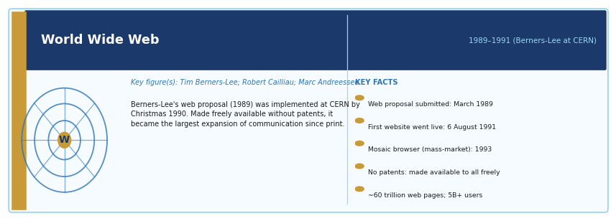
Period: 1989–1991 (proposal and first implementation); 1993 (Mosaic browser, public adoption) | Key figure(s): Tim Berners-Lee; Robert Cailliau; Marc Andreessen (Mosaic browser)
HISTORICAL CONTEXT
Tim Berners-Lee, a British physicist working at CERN, proposed a hypertext system for managing information in March 1989. With colleague Robert Cailliau, he implemented the first web server and web browser by Christmas 1990. The first web page went live at CERN on 6 August 1991. The web was made freely available, without patents or royalties — a decision that was arguably as consequential as the invention itself. Marc Andreessen's Mosaic browser (1993) made the web visually accessible to non-technical users.
SCIENTIFIC / TECHNOLOGICAL SIGNIFICANCE
The web is the user-facing layer of the internet — a system of linked documents (HTML) accessible through browsers. It was the mechanism by which the internet became a mass-market technology. Before the web, using the internet required technical expertise; after it, anyone could navigate to any information on Earth through a graphical interface. The web also enabled e-commerce, online media, social networking, and the modern digital economy.
IMPACT ON HUMANITY
The web has been called the largest expansion of human communication since the printing press. It contains an estimated 60 trillion individual pages, accessed by over 5 billion users. It has democratised publishing, reorganised retail, created new industries (search, social media, streaming, cloud computing), and fundamentally changed how information is produced, distributed, and consumed. Tim Berners-Lee continues to advocate for an open, non-centralised web through the World Wide Web Foundation.
MULTIMEDIA & FURTHER RESOURCES
▸ CERN: The World's First Website (Restored) — CERN
▸ TED Talk: Tim Berners-Lee — A Magna Carta for the Web — TED
▸ World Wide Web Foundation: History and Mission — WWF

Search Engines
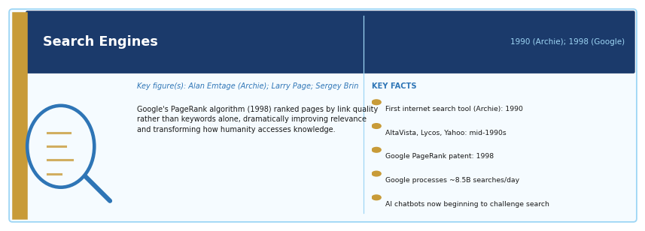
Period: 1990 (Archie, first internet search tool); 1998 (Google founded) | Key figure(s): Alan Emtage (Archie, 1990); Larry Page and Sergey Brin (Google, 1998)
HISTORICAL CONTEXT
The explosion of web content in the early 1990s immediately created a navigation problem: how to find specific information among millions of pages. Early engines — AltaVista, Lycos, Yahoo Directory — used keyword matching or human curation. Larry Page and Sergey Brin's PageRank algorithm (the basis of Google, founded 1998) ranked pages by the number and quality of links pointing to them, producing dramatically more useful results and transforming how people access information.
SCIENTIFIC / TECHNOLOGICAL SIGNIFICANCE
Search engines transformed access to knowledge from a librarian-mediated or encyclopaedia-lookup process to an instant, universal, self-directed one. Google's PageRank established a new paradigm: relevance ranked algorithmically rather than curated by human editors. The search engine is the primary tool through which most internet users navigate the entire corpus of human knowledge.
IMPACT ON HUMANITY
Google processes approximately 8.5 billion searches per day and commands over 90% of global search market share. Search advertising (based on user queries) is the primary business model of the digital economy, generating hundreds of billions of dollars annually. Search engines have fundamentally changed how knowledge is organised, accessed, and monetised — and they now face disruption from AI-powered language models that can answer questions conversationally rather than through ranked links.
MULTIMEDIA & FURTHER RESOURCES
▸ Google: How Search Works — Google
▸ Stanford: The Anatomy of a Large-Scale Search Engine (Original PageRank Paper) — Stanford

Satellite Technology
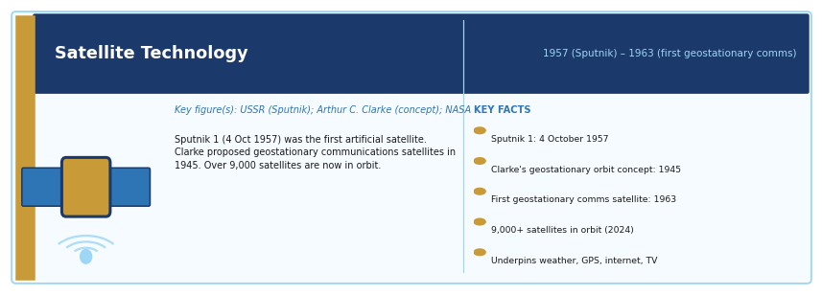
Period: 1957 (Sputnik 1, first artificial satellite); 1963 (first geostationary communication satellite) | Key figure(s): Soviet space programme (Sputnik); NASA; Arthur C. Clarke (geostationary orbit concept, 1945)
HISTORICAL CONTEXT
The USSR launched Sputnik 1 on 4 October 1957 — the first artificial Earth satellite. The concept of geostationary communication satellites had been described by Arthur C. Clarke in 1945. The first geostationary communications satellite, Syncom 3, was launched in 1964, demonstrating live intercontinental television. Today over 9,000 satellites are in orbit, including constellations of hundreds by SpaceX (Starlink), OneWeb, and Amazon.
SCIENTIFIC / TECHNOLOGICAL SIGNIFICANCE
Satellites enabled global telecommunications, live international television, weather forecasting, GPS navigation, Earth observation, scientific research, and military surveillance. They made it possible to monitor the entire surface of the Earth continuously, transforming our understanding of climate, agriculture, ocean dynamics, and environmental change.
IMPACT ON HUMANITY
Satellite technology underpins a multi-hundred-billion-dollar global industry including telecommunications, broadcasting, weather forecasting, remote sensing, and navigation. It enables precision agriculture, fisheries management, disaster response, maritime tracking, and climate monitoring. Low-Earth orbit (LEO) satellite constellations are now beginning to provide high-speed internet access to remote areas previously unserved by terrestrial networks.
MULTIMEDIA & FURTHER RESOURCES
▸ NASA: History of Satellites — NASA
▸ ESA: How Satellites Work — ESA

GPS (Global Positioning System)
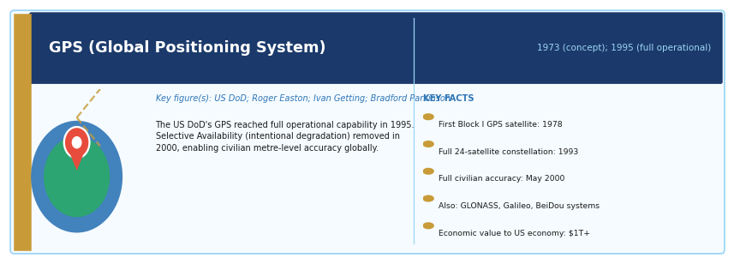
Period: 1973 (concept); 1978 (first satellites launched); 1995 (full operational capability) | Key figure(s): US Department of Defense; Roger L. Easton, Ivan Getting, Bradford Parkinson
HISTORICAL CONTEXT
GPS was developed by the US Department of Defense, building on earlier satellite-based navigation concepts (Transit, 1960). The first Block I GPS satellite was launched in 1978. The full 24-satellite constellation was completed in 1993. Originally restricted to military use with intentional degradation (Selective Availability) for civilians, it was made fully accurate for civilian use by President Clinton's order in 2000. Similar systems include GLONASS (Russia), Galileo (EU), and BeiDou (China).
SCIENTIFIC / TECHNOLOGICAL SIGNIFICANCE
GPS determines position and time anywhere on Earth with metre-level accuracy using signals from a constellation of satellites in medium Earth orbit. It is both a navigation system and a global timing infrastructure — the internet, financial systems, power grids, and mobile networks all use GPS time signals for synchronisation. Accuracy to the centimetre level is achievable with differential correction.
IMPACT ON HUMANITY
GPS is now deeply embedded in transportation, logistics, aviation, maritime navigation, precision agriculture, military operations, mapping, surveying, emergency services, ride-hailing, and smartphone navigation. Its economic contribution to the US economy alone is estimated at over $1 trillion since its opening (CGSIC). GPS-dependent systems are so critical to modern infrastructure that their failure — through jamming or spoofing — is considered a national security risk.
MULTIMEDIA & FURTHER RESOURCES
▸ GPS.gov: Official US Government GPS Portal — US Government
▸ NASA: How GPS Works — NASA

Semiconductor Technology
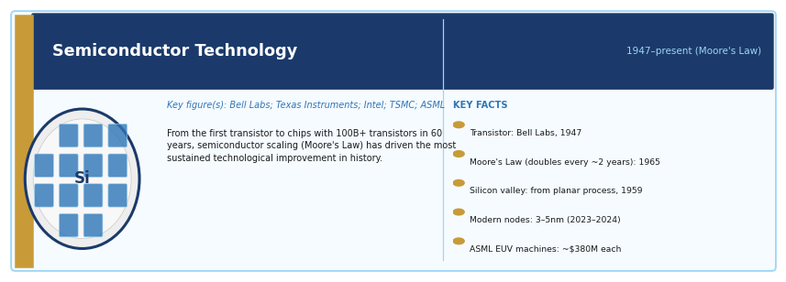
Period: 1947 (transistor); 1958 (IC); 1960s–present (Moore's Law scaling) | Key figure(s): Bell Labs; Texas Instruments; Intel; TSMC; ASML
HISTORICAL CONTEXT
A semiconductor is a material — most commonly silicon — whose electrical conductivity can be precisely controlled by adding impurities (doping) or applying electric fields. This controllability makes semiconductors ideal for transistors. The semiconductor industry has grown from room-sized vacuum tube computers to chips containing over 100 billion transistors on a piece of silicon smaller than a fingernail, following the trajectory predicted by Moore's Law (Gordon Moore, 1965).
SCIENTIFIC / TECHNOLOGICAL SIGNIFICANCE
Semiconductors are the physical substrate of all digital technology. The ability to manufacture transistors at nanometre scale (modern chips use 3–5 nm features) and to integrate billions of them on a single die has driven the exponential improvement in computing power, memory capacity, and energy efficiency that characterises the digital age.
IMPACT ON HUMANITY
The global semiconductor industry generates over $600 billion in revenue annually and is critical to virtually every other sector of the economy. Semiconductors are now a geopolitical flashpoint: the concentration of advanced chip manufacturing in Taiwan (TSMC) and South Korea (Samsung), and the dependence on the Dutch company ASML for the extreme ultraviolet (EUV) lithography machines needed to produce them, have made chip supply chains a central issue in US-China strategic competition.
MULTIMEDIA & FURTHER RESOURCES
▸ IEEE Spectrum: The International Technology Roadmap for Semiconductors — IEEE Spectrum
▸ ASML: How EUV Lithography Works (Video) — ASML
▸ Chip War — Chris Miller (Book Summary, CFR) — CFR

Laser
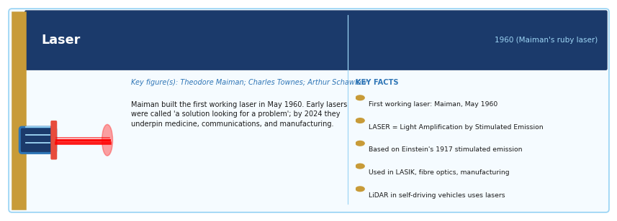
Period: 1960 (first working laser, Theodore Maiman); 1961 (first medical laser application) | Key figure(s): Theodore Maiman (first ruby laser, 1960); Charles Townes and Arthur Schawlow (theoretical basis, MASER)
HISTORICAL CONTEXT
The word LASER is an acronym: Light Amplification by Stimulated Emission of Radiation. Albert Einstein described stimulated emission in 1917 — the quantum mechanical principle that underlies the laser. Charles Townes built the first MASER (microwave version) in 1953. Theodore Maiman built the first working optical laser — a ruby crystal pumped by a flashlamp — in May 1960. Early lasers were famously described as 'a solution looking for a problem'; by the 21st century they had found thousands.
SCIENTIFIC / TECHNOLOGICAL SIGNIFICANCE
Lasers produce coherent, monochromatic, highly directional light. This makes them uniquely useful for precision cutting, measuring, communicating, and imaging. They are used in eye surgery (LASIK), cancer treatment (photodynamic therapy), skin dermatology, dental procedures, fibre-optic communication (carrying internet data), barcode scanners, CD/DVD/Blu-ray players, laser printers, manufacturing (metal cutting and welding), and precision measurement.
IMPACT ON HUMANITY
Lasers are central to the modern economy. Fibre-optic cables carrying laser light pulses carry the vast majority of the world's internet traffic. Laser cutting and welding are essential in manufacturing. LiDAR (laser ranging) is fundamental to self-driving vehicles. Laser cooling has enabled advances in atomic physics and quantum computing. High-power lasers are being developed for missile defence and materials processing.
MULTIMEDIA & FURTHER RESOURCES
▸ American Physical Society: History of the Laser — APS
▸ How Lasers Work (HowStuffWorks) — HowStuffWorks

Fibre-Optic Communication
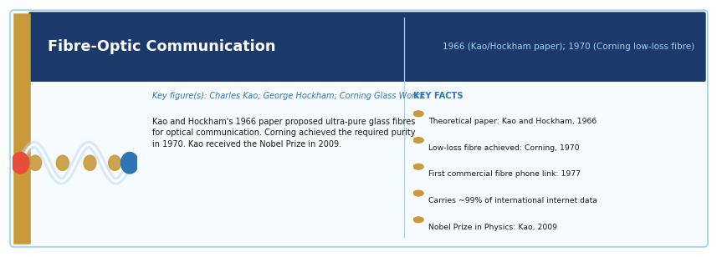
Period: 1966 (Kao and Hockham's theoretical paper); 1970 (Corning's low-loss glass fibre); commercial deployment from 1980s | Key figure(s): Charles Kao (Nobel Prize 2009); George Hockham; Robert Maurer, Donald Keck, Peter Schultz (Corning)
HISTORICAL CONTEXT
Charles Kao and George Hockham proposed in 1966 that glass fibre could carry light signals over long distances if its purity could be sufficiently improved. Corning Glass Works achieved the required low-loss fibre in 1970. The first fibre-optic telephone link was installed in 1977 in Chicago. By the 1990s, undersea fibre-optic cables were replacing satellite links as the backbone of international telecommunications, offering far greater bandwidth.
SCIENTIFIC / TECHNOLOGICAL SIGNIFICANCE
Fibre-optic cables carry information as pulses of laser light through ultra-pure glass threads thinner than a human hair. A single fibre can carry terabits of data per second — far exceeding the capacity of copper cables. The global network of undersea fibre-optic cables now carries approximately 99% of all international data traffic, including internet traffic, phone calls, and financial transactions.
IMPACT ON HUMANITY
Fibre optics is the physical backbone of the global internet. Without it, the bandwidth required for video streaming, cloud computing, videoconferencing, and financial market data would not be achievable. The global undersea cable network represents tens of billions of dollars of infrastructure and is considered critical national infrastructure by most governments. Sabotage or failure of these cables would severely disrupt global communication.
MULTIMEDIA & FURTHER RESOURCES
▸ TeleGeography: Submarine Cable Map — TeleGeography
▸ Nobel Prize: Charles Kao — Fibre Optics (2009) — Nobel Prize
▸ Corning: History of Optical Fibre — Corning

Spaceflight
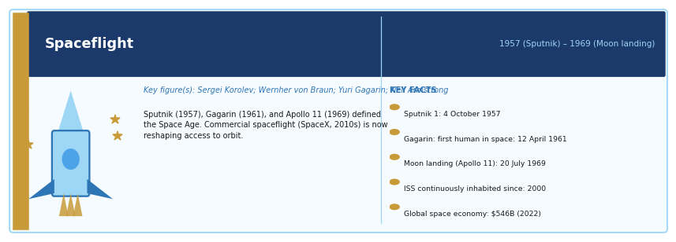
Period: 1957 (Sputnik); 1961 (first human in space, Gagarin); 1969 (Moon landing) | Key figure(s): Sergei Korolev (Soviet); Wernher von Braun (US); NASA; Yuri Gagarin; Neil Armstrong
HISTORICAL CONTEXT
The Space Age began with Sputnik 1 (1957). Yuri Gagarin became the first human in space on 12 April 1961 (Vostok 1). Neil Armstrong and Buzz Aldrin landed on the Moon on 20 July 1969 (Apollo 11). The Space Shuttle programme (1981–2011) made orbital spaceflight somewhat routine. Since 2000, the International Space Station has been continuously inhabited. The 2010s saw the emergence of commercial spaceflight (SpaceX, Blue Origin, Virgin Galactic) and reusable rocket technology.
SCIENTIFIC / TECHNOLOGICAL SIGNIFICANCE
Spaceflight provided the platforms for weather satellites, communications satellites, GPS, Earth observation, and scientific instruments such as the Hubble and James Webb space telescopes. It demonstrated that human beings can survive and work in space. It also transformed our understanding of Earth: the 'Overview Effect' experienced by astronauts — seeing the Earth as a fragile sphere in space — has influenced environmental thinking.
IMPACT ON HUMANITY
The global space economy exceeded $546 billion in 2022. Space technology underpins navigation, weather forecasting, telecommunications, environmental monitoring, and national security. The new commercial space era, driven by reusable rockets and falling launch costs, is opening access to orbit for new satellites, space tourism, and eventually lunar and Mars missions. The Artemis programme aims to return humans to the Moon in the mid-2020s.
MULTIMEDIA & FURTHER RESOURCES
▸ NASA: History of Human Spaceflight — NASA
▸ Apollo 11 Mission (50th Anniversary Resources, Smithsonian) — Smithsonian
▸ ESA: Overview of Space Science — ESA

Smartphones
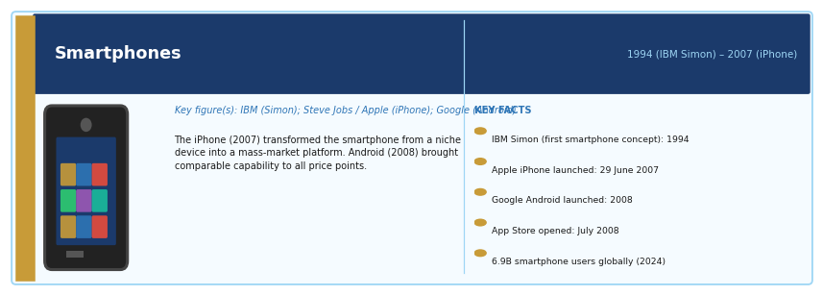
Period: 1992 (IBM Simon, first smartphone concept); 2007 (iPhone, mass market transformation) | Key figure(s): IBM (Simon, 1994); Apple (iPhone, 2007, Steve Jobs); Google (Android, 2008)
HISTORICAL CONTEXT
The IBM Simon (1994) combined a mobile phone with email, a calendar, and a touch screen — the first device recognisable as a smartphone. Nokia dominated mobile phones through the 2000s. Apple's iPhone (2007) was a watershed: it combined a touch-screen interface, internet browser, music player, camera, and eventually an app ecosystem in a device that was genuinely mass-market. Google's Android (2008) brought a similar capability to devices across all price points.
SCIENTIFIC / TECHNOLOGICAL SIGNIFICANCE
Smartphones are the most rapidly adopted technology in history. They combined phone, internet, camera, GPS, music player, banking terminal, and supercomputer into one pocket device. The app economy — enabled by Apple's App Store (2008) — created entirely new industries (ride-hailing, food delivery, social media, mobile gaming) and transformed existing ones (banking, retail, media, healthcare).
IMPACT ON HUMANITY
As of 2024, approximately 6.9 billion people use smartphones — nearly 86% of the world's population. In many developing countries, mobile phones leapfrogged fixed-line infrastructure, giving hundreds of millions their first access to banking (mobile money, M-Pesa), healthcare information, and the internet. Smartphones have also driven significant social harms, including concerns about addiction, mental health (especially among adolescents), privacy surveillance, and disinformation.
MULTIMEDIA & FURTHER RESOURCES
▸ Computer History Museum: Mobile Phone History — CHM
▸ Our World in Data: Smartphone Adoption — Our World in Data

Social Media Platforms
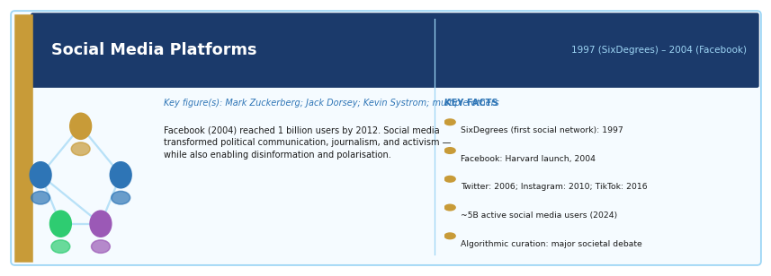
Period: 1997 (SixDegrees, first recognisable social network); 2004 (Facebook); 2006 (Twitter) | Key figure(s): Mark Zuckerberg (Facebook); Jack Dorsey (Twitter); Kevin Systrom (Instagram); multiple others
HISTORICAL CONTEXT
Early social networks included SixDegrees (1997) and Friendster (2002). MySpace (2003) was briefly the world's largest website. Facebook, launched in 2004 at Harvard, expanded globally and reached 1 billion users by 2012. Twitter (2006), YouTube (2005), Instagram (2010), Snapchat (2011), TikTok (2016), and others followed. As of 2024, there are approximately 5 billion active social media users worldwide.
SCIENTIFIC / TECHNOLOGICAL SIGNIFICANCE
Social media platforms are the dominant communication infrastructure for personal relationships, journalism, political discourse, marketing, and entertainment in the digital age. They enabled user-generated content at global scale, creating new forms of celebrity, activism, journalism, and cultural production. They also created algorithmic curation of information — a fundamental change in how public discourse is organised.
IMPACT ON HUMANITY
Social media has accelerated political movements (Arab Spring, #MeToo, Black Lives Matter), enabled real-time global communication, given individuals the power to broadcast to millions, and created advertising businesses worth trillions. It has also been associated with the spread of disinformation, political polarisation, cyberbullying, mental health problems (especially in adolescents), and manipulation by state and commercial actors. The societal consequences of platform algorithms that maximise engagement are among the most debated issues in technology policy.
MULTIMEDIA & FURTHER RESOURCES
▸ Our World in Data: Social Media Use — Our World in Data
▸ Netflix: The Social Dilemma (Documentary, 2020) — Netflix
▸ Pew Research: Social Media and Society — Pew Research

7. Emerging and Transformative Technologies

Artificial Intelligence
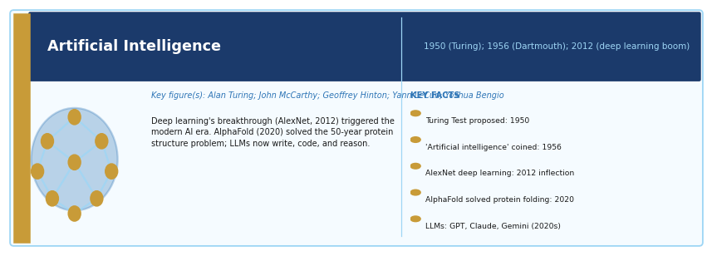
Period: 1950 (Turing's test); 1956 (Dartmouth Conference, AI coined); current boom from 2012 | Key figure(s): Alan Turing; John McCarthy; Marvin Minsky; Geoffrey Hinton; Yann LeCun; Yoshua Bengio
HISTORICAL CONTEXT
Alan Turing proposed the 'imitation game' (the Turing test) in 1950. The Dartmouth Conference in 1956, organised by John McCarthy, coined the term 'artificial intelligence'. Early AI went through periods of optimism and disillusionment ('AI winters'). The current era was inaugurated by deep learning — the application of neural networks with many layers to large datasets — pioneered by Geoffrey Hinton, Yann LeCun, and Yoshua Bengio in the 2000s–2010s. AlexNet's victory in the ImageNet competition (2012) is often taken as the inflection point.
SCIENTIFIC / TECHNOLOGICAL SIGNIFICANCE
Modern AI — particularly deep learning — has achieved human-level or superhuman performance in image recognition, game-playing (chess, Go, video games), protein structure prediction (AlphaFold, 2020), language generation (GPT series, Claude), and scientific discovery. Large language models (LLMs) trained on vast text corpora can write, reason, code, translate, summarise, and converse in ways that were considered decades away only ten years ago.
IMPACT ON HUMANITY
AI is beginning to transform drug discovery (AlphaFold solved the 50-year protein structure problem), medical diagnosis (AI matches or exceeds radiologists in some imaging tasks), software development (AI coding assistants), scientific research (climate modelling, materials science), and language translation. Concerns include job displacement, algorithmic bias, misuse for disinformation and surveillance, concentration of power in a small number of companies, and long-term safety risks from increasingly capable systems.
MULTIMEDIA & FURTHER RESOURCES
▸ DeepMind: AlphaFold — Solving the Protein Structure Problem — DeepMind
▸ Our World in Data: Artificial Intelligence — Our World in Data
▸ MIT: AI and the Future of Work (Online Course) — MIT
▸ Turing Institute: AI Ethics and Safety Resources — Turing Institute

Renewable Energy Technologies
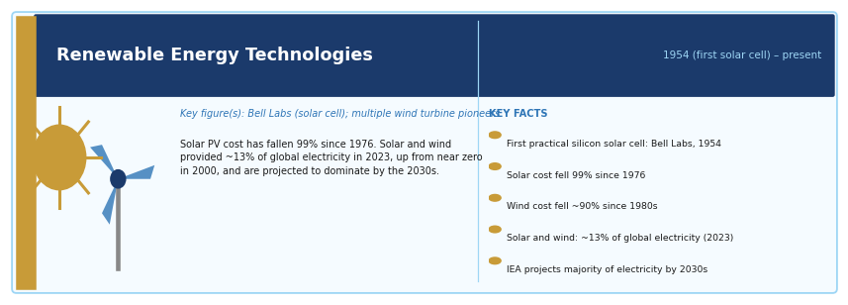
Period: 1954 (first practical silicon solar cell); 1970s–present (wind, solar, storage development) | Key figure(s): Bell Labs (silicon solar cell, 1954); Darrieus and other wind turbine pioneers; multiple researchers
HISTORICAL CONTEXT
Photovoltaic solar cells were first developed at Bell Labs in 1954. Early solar cells were expensive and used mainly in space applications. Wind turbines for electricity generation developed commercially from the 1970s energy crisis. The cost of solar photovoltaics has fallen by approximately 99% since 1976, and the cost of wind energy by roughly 90%. Renewable electricity is now the cheapest form of electricity generation in most of the world on a levelised cost basis.
SCIENTIFIC / TECHNOLOGICAL SIGNIFICANCE
Renewable energy technologies — solar photovoltaics, wind turbines, hydropower, geothermal, and tidal — generate electricity without burning fuel and without greenhouse gas emissions. As the world faces the challenge of decarbonising its energy system to address climate change, these technologies are the primary technical pathway. The combination of falling costs and improving battery storage is reshaping the global energy system.
IMPACT ON HUMANITY
Solar and wind together provided approximately 13% of global electricity generation in 2023, up from near zero in 2000. The IEA projects they will provide the majority of electricity globally by the 2030s under accelerated transition scenarios. The energy transition also has geopolitical implications: unlike oil and gas, solar and wind resources are widely distributed, potentially reducing the geopolitical dependence on fossil fuel exporters.
MULTIMEDIA & FURTHER RESOURCES
▸ Our World in Data: Renewable Energy — Our World in Data
▸ IEA: World Energy Outlook (Annual Report) — IEA
▸ TED Talk: Ramez Naam — The Case for Optimism on Climate Change — TED

Battery Technology
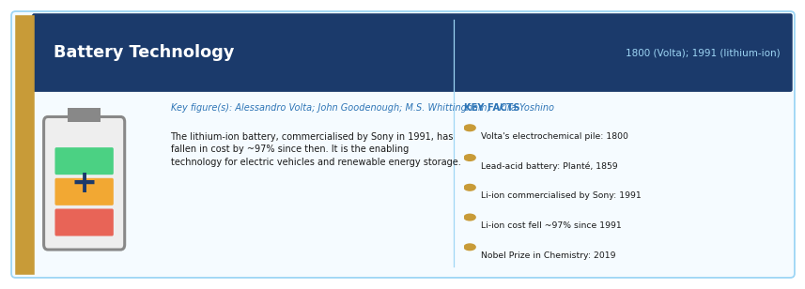
Period: 1800 (Volta's pile, first battery); 1991 (Sony's first commercial lithium-ion battery) | Key figure(s): Alessandro Volta (electrochemical battery, 1800); John Goodenough, M. Stanley Whittingham, Akira Yoshino (lithium-ion battery — Nobel Prize 2019)
HISTORICAL CONTEXT
Alessandro Volta invented the first electrochemical battery in 1800 — the Voltaic pile. Lead-acid batteries (Planté, 1859) powered early electric vehicles and telephone exchanges. The lithium-ion battery, developed over decades by Whittingham, Goodenough, and Yoshino and commercialised by Sony in 1991, transformed portable electronics. The cost of lithium-ion batteries has fallen approximately 97% since 1991, enabling electric vehicles and grid-scale energy storage.
SCIENTIFIC / TECHNOLOGICAL SIGNIFICANCE
Batteries store electrical energy chemically and release it on demand. They are the enabling technology for portable electronics (all smartphones, laptops, and tablets), electric vehicles, and the integration of intermittent renewable energy (solar and wind) into reliable electrical grids. Without affordable, high-energy-density batteries, the transition to electric transport and renewable electricity is impossible.
IMPACT ON HUMANITY
Lithium-ion batteries have powered the mobile revolution — enabling smartphones, tablets, and laptops. They are now central to electric vehicles (approximately 40% of all new passenger cars sold globally were electric or plug-in hybrid by 2024 in leading markets). Grid-scale battery storage is beginning to enable grids to run on predominantly renewable energy by storing excess generation. Challenges include lithium and cobalt supply chains, battery recycling, and the development of next-generation chemistries.
MULTIMEDIA & FURTHER RESOURCES
▸ Nobel Prize: Goodenough, Whittingham, Yoshino — Lithium-Ion Battery (2019) — Nobel Prize
▸ Our World in Data: Battery Costs and Electric Vehicles — Our World in Data

Electric Vehicles
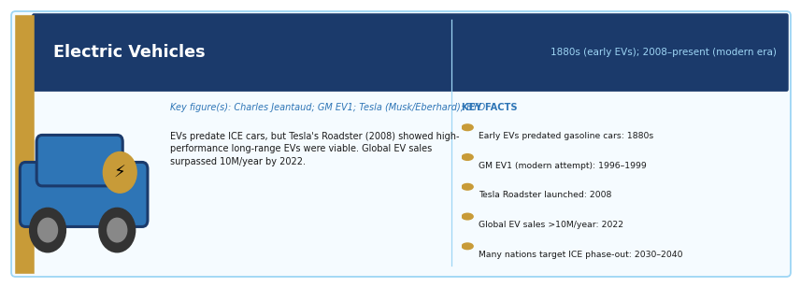
Period: 1880s (early EVs); 1990s (GM EV1); 2008–present (Tesla and the modern EV era) | Key figure(s): Charles Jeantaud (France, 1881); GM EV1 (1996); Elon Musk / Martin Eberhard (Tesla, 2003)
HISTORICAL CONTEXT
Electric vehicles predate the internal combustion engine — early EVs by Camille Faure and Charles Jeantaud appeared in the 1880s, and electric taxis were common in cities at the turn of the 20th century. ICE vehicles won out due to greater range and cheaper fuel. GM's EV1 (1996–1999) was a modern attempt that was discontinued. Tesla's Roadster (2008) and Model S (2012) demonstrated that high-performance long-range EVs were commercially viable, triggering massive investment by all major automakers.
SCIENTIFIC / TECHNOLOGICAL SIGNIFICANCE
Electric vehicles eliminate tailpipe emissions, offer lower running costs and simpler mechanics than ICE vehicles, and can be powered by renewable electricity. Combined with renewable energy, they represent a path to near-zero-emission personal transport. They also enable new vehicle architectures (flat skateboard platforms, over-the-air software updates) that are transforming the automotive industry.
IMPACT ON HUMANITY
Global EV sales surpassed 10 million per year by 2022. China is the world's largest EV market. Multiple major economies have set targets to phase out new ICE vehicle sales between 2030 and 2040. EVs are reshaping the automotive supply chain (reducing demand for ICE components, increasing demand for batteries and semiconductor chips), the oil industry (reducing fuel demand), and urban air quality.
MULTIMEDIA & FURTHER RESOURCES
▸ Our World in Data: Electric Vehicles — Our World in Data
▸ IEA: Global EV Outlook (Annual Report) — IEA

Robotics
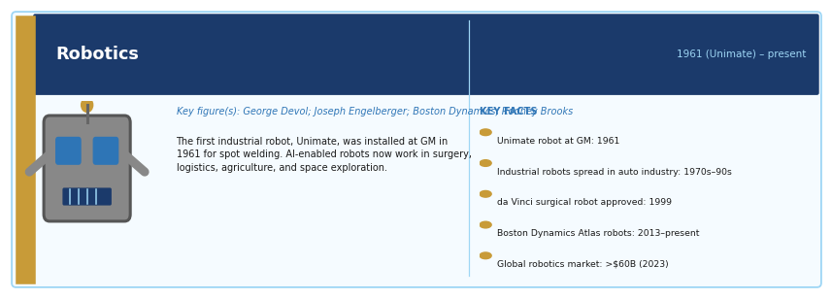
Period: 1961 (Unimate, first industrial robot); 1970s (automated manufacturing); 21st century (AI-enabled robotics) | Key figure(s): George Devol (Unimate, 1961); Joseph Engelberger; Boston Dynamics; Rodney Brooks; Masahiro Mori
HISTORICAL CONTEXT
The first industrial robot, Unimate, was installed at a General Motors plant in 1961 to perform spot welding and part extraction. Industrial robots spread through automobile manufacturing in the 1970s–1990s. Surgical robots (da Vinci system, 1999) extended robotics to medicine. Advanced mobile robots (Boston Dynamics, iRobot) demonstrated locomotion over complex terrain. AI-enabled robots now adapt to unstructured environments in ways previously impossible.
SCIENTIFIC / TECHNOLOGICAL SIGNIFICANCE
Robotics combines mechanical engineering, sensors, computing, and artificial intelligence to create machines that can perform physical tasks autonomously or semi-autonomously. Industrial robots increase precision, consistency, and speed in manufacturing. Surgical robots enable minimally invasive procedures with greater accuracy than human hands alone. Service robots are beginning to assist with logistics, cleaning, and care for the elderly.
IMPACT ON HUMANITY
The global robotics market was estimated at over $60 billion in 2023 and growing rapidly. Industrial robots are central to automobile, electronics, and pharmaceutical manufacturing. The pandemic accelerated adoption of logistics robots (warehouse automation). Concerns about robotics include job displacement in manufacturing and services, and — for military applications — the autonomous weapons systems debate.
MULTIMEDIA & FURTHER RESOURCES
▸ IEEE Robotics and Automation Society: Robotics News and Resources — IEEE
▸ Boston Dynamics: Robot Videos and Technology — Boston Dynamics

3D Printing (Additive Manufacturing)
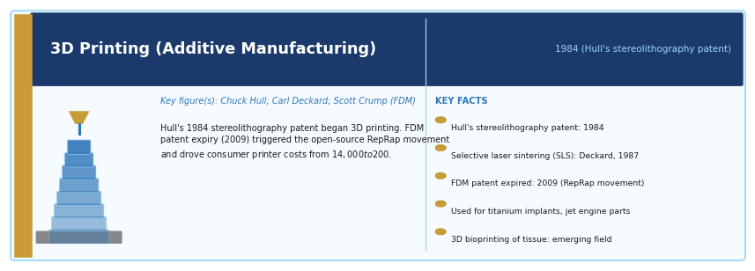
Period: 1984 (Chuck Hull's stereolithography patent); commercial use from 1990s; mainstream from 2010s | Key figure(s): Chuck Hull (stereolithography, 1984); Carl Deckard (SLS); Scott Crump (FDM, Stratasys)
HISTORICAL CONTEXT
Chuck Hull patented stereolithography — building three-dimensional objects layer by layer using UV-cured resin — in 1984 and co-founded 3D Systems. Carl Deckard developed selective laser sintering (SLS) at UT Austin in 1987. Scott Crump invented fused deposition modelling (FDM) in 1989, the process used by most consumer 3D printers. The expiry of key FDM patents in 2009 triggered the RepRap open-source movement and a dramatic reduction in printer costs.
SCIENTIFIC / TECHNOLOGICAL SIGNIFICANCE
3D printing can produce complex three-dimensional objects from digital designs without moulds or subtractive machining. It enables rapid prototyping, customised medical implants (titanium bone implants, dental prosthetics), aerospace parts (jet engine components, rocket nozzles), architectural models, and production of low-volume components economically. Medical bioprinting — printing living tissue from cells — is an emerging application.
IMPACT ON HUMANITY
3D printing is transforming product development by compressing the prototype-to-production cycle from months to days. It enables personalised medicine (hearing aids, orthotics, implants all routinely made by 3D printing). SpaceX, Boeing, and other aerospace companies use it for production rocket and aircraft components. 3D-printed houses are being constructed in several countries to address housing shortages. Bioprinting of functional organs for transplantation remains a long-term research goal.
MULTIMEDIA & FURTHER RESOURCES
▸ Smithsonian: History of 3D Printing — Smithsonian
▸ TED Talk: Anthony Atala — Printing a Human Kidney (3D bioprinting) — TED

Blockchain
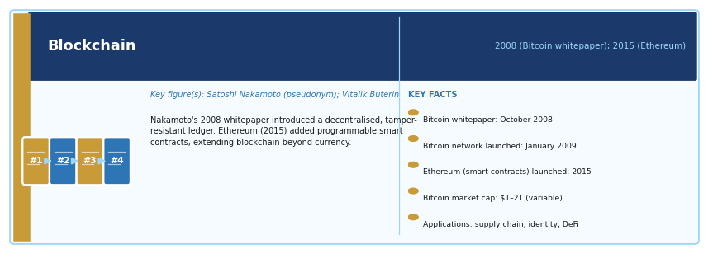
Period: 2008 (Bitcoin whitepaper by Satoshi Nakamoto); 2015 (Ethereum smart contracts) | Key figure(s): Satoshi Nakamoto (pseudonym, identity unknown); Vitalik Buterin (Ethereum)
HISTORICAL CONTEXT
The blockchain concept was introduced in Satoshi Nakamoto's 2008 whitepaper 'Bitcoin: A Peer-to-Peer Electronic Cash System'. Bitcoin launched in January 2009. Ethereum, proposed by Vitalik Buterin in 2013 and launched in 2015, extended the blockchain concept to programmable 'smart contracts'. Blockchain is a distributed ledger — a database maintained simultaneously by many nodes, with each block of records cryptographically linked to the previous one, making alteration without detection extremely difficult.
SCIENTIFIC / TECHNOLOGICAL SIGNIFICANCE
Blockchain technology enables trustless, transparent, immutable record-keeping without a central authority. This has applications in digital currencies, supply chain provenance tracking, digital ownership (NFTs), decentralised finance (DeFi), voting systems, and land registry. Its core innovation is the ability for parties who do not trust each other to maintain a shared record without a trusted intermediary.
IMPACT ON HUMANITY
Bitcoin remains the most widely held cryptocurrency (market capitalisation of $1–2 trillion depending on market conditions). Blockchain technology is being piloted for supply chain transparency (food safety, pharmaceutical track-and-trace), digital identity, cross-border payments, and financial infrastructure in underbanked regions. The technology is also controversial: cryptocurrency mining consumes significant energy, and speculative trading has caused financial harm to many retail investors.
MULTIMEDIA & FURTHER RESOURCES
▸ MIT OpenCourseWare: Blockchain and Money — MIT OCW
▸ Bitcoin Whitepaper: Original Satoshi Nakamoto Paper — Bitcoin.org
▸ Our World in Data: Cryptocurrency and Energy Use — Our World in Data

Cloud Computing
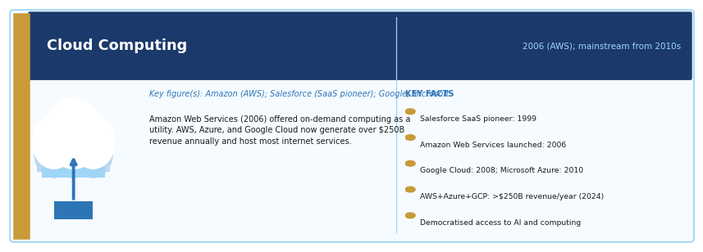
Period: 2006 (Amazon Web Services launch); 2008–2010 (Google Cloud, Microsoft Azure); mainstream from 2010s | Key figure(s): Amazon Web Services (Jeff Bezos, Andy Jassy); Salesforce (Marc Benioff, early SaaS); Google; Microsoft
HISTORICAL CONTEXT
The concept of delivering computing resources as a utility over a network was discussed in the 1960s (John McCarthy, MIT). Salesforce pioneered software-as-a-service (SaaS) in 1999. Amazon Web Services, launched in 2006, offered elastic on-demand computing infrastructure (virtual servers, storage, databases) on a pay-as-you-go basis, transforming the economics of software development and deployment. Microsoft Azure (2010) and Google Cloud (2008/2010) followed.
SCIENTIFIC / TECHNOLOGICAL SIGNIFICANCE
Cloud computing allows organisations to access computing power, storage, and software without owning or maintaining physical infrastructure. It enables businesses to scale instantly, pay for only what they use, and access sophisticated computing capabilities (AI, machine learning, data analytics) that would otherwise require massive capital investment. It democratises access to computing in the same way electricity utilities democratised access to power.
IMPACT ON HUMANITY
Cloud computing is the infrastructure layer of the modern digital economy. Virtually all major internet services (streaming, social media, e-commerce, AI services) run on cloud infrastructure. The three largest providers — Amazon AWS, Microsoft Azure, and Google Cloud — share revenues of over $250 billion annually. Cloud computing has reduced the barrier to entry for startups (eliminating the need for data centres) and has made AI services economically accessible to organisations of all sizes.
MULTIMEDIA & FURTHER RESOURCES
▸ AWS: What is Cloud Computing? — AWS
▸ MIT Technology Review: The History of Cloud Computing — MIT Technology Review

8. Concise Top 20 Summary
The following twenty developments represent a compact core of civilisation-changing breakthroughs, selected for transformative breadth and depth of impact across the full scope of human history:

Rank | Breakthrough
1 | Controlled fire
2 | Agriculture
3 | Writing
4 | Mathematics and zero
5 | Paper
6 | Printing press
7 | Scientific method
8 | Microscope
9 | Telescope
10 | Steam engine
11 | Vaccination
12 | Electricity
13 | Germ theory
14 | Antibiotics
15 | Internal combustion engine
16 | Airplane
17 | Transistor
18 | Computer
19 | Internet
20 | Artificial intelligence

Concluding Note
These inventions, discoveries, and innovations do not constitute a complete history of science and technology. Rather, they form a curated reference of milestones whose cumulative effects reshaped human survival, knowledge, production, health, communication, mobility, and everyday life. Many are deeply interconnected: electricity, electromagnetism, semiconductors, computers, the internet, and artificial intelligence form one continuous chain of modern technological transformation; the germ theory of disease, microscopy, vaccination, antibiotics, and DNA structure form another in medicine.

The multimedia and external resources listed throughout this document — drawn from the Nobel Prize archive, Smithsonian Institution, NASA, WHO, Our World in Data, BBC, PBS, MIT OpenCourseWare, TED, and leading academic publishers — are intended to support readers who wish to explore any topic in greater depth. They represent a starting point rather than an exhaustive bibliography.

Prepared as an expanded structured reference document — June 2026

References
The following references are organised by category and listed alphabetically within each group. They include the primary scholarly and institutional sources consulted in preparing this document, together with all multimedia and online resources cited in the individual entries. Online resources include the source organisation, title, and URL. Where a specific publication date or access date is relevant it is noted. References are formatted consistently using an adapted Chicago/APA hybrid style suitable for a multi-source reference document of this kind.

A. Books and Major Scholarly Works

Basalla, George. The Evolution of Technology. Cambridge: Cambridge University Press, 1988.
Bijker, Wiebe E., Thomas P. Hughes, and Trevor Pinch, eds. The Social Construction of Technological Systems. Cambridge, MA: MIT Press, 1987.
Burke, James. Connections. London: Macmillan, 1978. [Companion to the BBC television series of the same name.]
Diamond, Jared. Guns, Germs, and Steel: The Fates of Human Societies. New York: Norton, 1997.
Eisenstein, Elizabeth L. The Printing Press as an Agent of Change. Cambridge: Cambridge University Press, 1979.
Feynman, Richard P., Robert B. Leighton, and Matthew Sands. The Feynman Lectures on Physics. 3 vols. Reading, MA: Addison-Wesley, 1963–1965. [Also available freely online at https://www.feynmanlectures.caltech.edu/]
Harari, Yuval Noah. Sapiens: A Brief History of Humankind. London: Harvill Secker, 2011.
Johnson, Steven. How We Got to Now: Six Innovations That Made the Modern World. New York: Riverhead Books, 2014.
Landes, David S. The Wealth and Poverty of Nations. New York: Norton, 1998.
McClellan, James E., and Harold Dorn. Science and Technology in World History. 3rd ed. Baltimore: Johns Hopkins University Press, 2015.
Miller, Chris. Chip War: The Fight for the World's Most Critical Technology. New York: Scribner, 2022.
Mokyr, Joel. The Lever of Riches: Technological Creativity and Economic Progress. Oxford: Oxford University Press, 1990.
Nye, David E. Technology Matters: Questions to Live With. Cambridge, MA: MIT Press, 2006.
Rhodes, Richard. The Making of the Atomic Bomb. New York: Simon & Schuster, 1986.
Scott, James C. Against the Grain: A Deep History of the Earliest States. New Haven: Yale University Press, 2017.
Standage, Tom. The Victorian Internet: The Remarkable Story of the Telegraph and the Nineteenth Century's Online Pioneers. New York: Walker, 1998.
Winchester, Simon. The Perfectionists: How Precision Engineers Created the Modern World. New York: HarperCollins, 2018.
Wrangham, Richard. Catching Fire: How Cooking Made Us Human. New York: Basic Books, 2009.

B. Peer-Reviewed Articles and Original Scientific Papers

Avery, Oswald T., Colin M. MacLeod, and Maclyn McCarty. 'Studies on the Chemical Nature of the Substance Inducing Transformation of Pneumococcal Types.' Journal of Experimental Medicine 79, no. 2 (1944): 137–158.
Charpentier, Emmanuelle, and Jennifer A. Doudna. 'A Programmable Dual-RNA–Guided DNA Endonuclease in Adaptive Bacterial Immunity.' Science 337, no. 6096 (2012): 816–821. https://doi.org/10.1126/science.1225829
Hounsfield, Godfrey N. 'Computerized Transverse Axial Scanning (Tomography).' British Journal of Radiology 46, no. 552 (1973): 1016–1022.
Jenner, Edward. An Inquiry into the Causes and Effects of the Variolae Vaccinae. London: Sampson Low, 1798. [Digitised at the Wellcome Collection: https://wellcomecollection.org/]
Kao, Charles K., and George A. Hockham. 'Dielectric-Fibre Surface Waveguides for Optical Frequencies.' Proceedings of the Institution of Electrical Engineers 113, no. 7 (1966): 1151–1158.
Maiman, Theodore H. 'Stimulated Optical Radiation in Ruby.' Nature 187 (1960): 493–494. https://doi.org/10.1038/187493a0
Moore, Gordon E. 'Cramming More Components onto Integrated Circuits.' Electronics 38, no. 8 (1965): 114–117.
Nakamoto, Satoshi. 'Bitcoin: A Peer-to-Peer Electronic Cash System.' 2008. https://bitcoin.org/bitcoin.pdf
Page, Lawrence, Sergey Brin, Rajeev Motwani, and Terry Winograd. 'The PageRank Citation Ranking: Bringing Order to the Web.' Stanford Digital Library Technologies Project, 1998. http://infolab.stanford.edu/~backrub/google.html
Röntgen, Wilhelm Conrad. 'Über eine neue Art von Strahlen.' Sitzungsberichte der Würzburger Physikalisch-Medicinischen Gesellschaft, 1895. [Nobel lecture available at: https://www.nobelprize.org/prizes/physics/1901/rontgen/lecture/]
Watson, James D., and Francis H. C. Crick. 'Molecular Structure of Nucleic Acids: A Structure for Deoxyribose Nucleic Acid.' Nature 171 (1953): 737–738. https://doi.org/10.1038/171737a0
Lander, Eric S., et al. (International Human Genome Sequencing Consortium). 'Initial Sequencing and Analysis of the Human Genome.' Nature 409 (2001): 860–921. https://doi.org/10.1038/35057062

C. Institutional and Government Publications and Reports

Centers for Disease Control and Prevention (CDC). 'Achievements in Public Health, 1900–1999: Safer and Healthier Foods.' Morbidity and Mortality Weekly Report 48, no. 40 (1999). https://www.cdc.gov/mmwr/
Centers for Disease Control and Prevention (CDC). 'Water Fluoridation: A Century of Progress.' Public Health Reports (2008). https://www.cdc.gov/
International Energy Agency (IEA). Global EV Outlook 2024. Paris: IEA, 2024. https://www.iea.org/reports/global-ev-outlook-2024
International Energy Agency (IEA). World Energy Outlook 2024. Paris: IEA, 2024. https://www.iea.org/reports/world-energy-outlook-2024
International Atomic Energy Agency (IAEA). Nuclear Power and Climate Change. Vienna: IAEA, 2023. https://www.iaea.org/topics/nuclear-power
NASA. History of Human Spaceflight. NASA History Division, 2019. https://www.nasa.gov/specials/60counting/
National Human Genome Research Institute (NHGRI). 'The Human Genome Project.' National Institutes of Health, 2023. https://www.genome.gov/human-genome-project
Pew Research Center. 'Social Media Use in 2024.' Washington, DC: Pew Research Center, 2024. https://www.pewresearch.org/topic/internet-technology/platforms-services/social-media/
United Nations Children's Fund (UNICEF) and World Health Organization (WHO). Progress on Household Drinking Water, Sanitation and Hygiene 2000–2022. Geneva: WHO, 2023.
World Health Organization (WHO). 'History of Vaccination.' Geneva: WHO, 2023. https://www.who.int/news-room/spotlight/history-of-vaccination
World Health Organization (WHO). 'Antimicrobial Resistance.' Fact Sheet. Geneva: WHO, 2023. https://www.who.int/news-room/fact-sheets/detail/antimicrobial-resistance
Roser, Max, Hannah Ritchie, and Bernadeta Dadonaite. 'Vaccination.' Our World in Data, 2024. https://ourworldindata.org/vaccination
Ritchie, Hannah, Pablo Rosado, and Max Roser. 'Plastic Pollution.' Our World in Data, 2023. https://ourworldindata.org/plastic-pollution
Ritchie, Hannah, and Max Roser. 'Renewable Energy.' Our World in Data, 2024. https://ourworldindata.org/renewable-energy
Roser, Max. 'Artificial Intelligence.' Our World in Data, 2024. https://ourworldindata.org/artificial-intelligence

D. Museum, Archive, and Library Resources

British Library. Gutenberg Bible Online. London: British Library, n.d. https://www.bl.uk/gutenberg-bible
Cambridge University Library. Newton's Principia Mathematica (digitised). Cambridge: Cambridge Digital Library, n.d. https://cudl.lib.cam.ac.uk/view/PR-ADV-B-00039-00001
Computer History Museum. 'The Transistor: A Timeline.' Mountain View, CA: CHM, 2023. https://computerhistory.org/stories/transistor/
Computer History Museum. 'The Microchip.' Mountain View, CA: CHM, 2023. https://computerhistory.org/stories/integrated-circuit/
Computer History Museum. 'History of Computing.' Mountain View, CA: CHM, 2023. https://computerhistory.org/
Einstein Archive Online. The Collected Papers of Albert Einstein. Jerusalem: Hebrew University, 2024. https://www.alberteinstein.info/
Henry Ford Museum of American Innovation. 'Stories of Innovation.' Dearborn, MI: The Henry Ford, 2024. https://www.thehenryford.org/explore/stories-of-innovation/
Library of Congress. Alexander Graham Bell Collection. Washington, DC: Library of Congress, n.d. https://www.loc.gov/collections/alexander-graham-bell/
Massachusetts General Hospital (MGH). 'The Ether Dome: History of Anaesthesia.' Boston: MGH, 2024. https://www.massgeneral.org/museum/exhibit/ether-dome
National Museum of American History, Smithsonian Institution. Various object records cited throughout this document. Washington, DC: Smithsonian, n.d. https://americanhistory.si.edu/
Royal Society. Newton's Papers Online. London: The Royal Society, 2024. https://royalsociety.org/collections/newton/
Science Museum, London. Steam Engine Collection and History of the Internal Combustion Engine. London: Science Museum Group, 2024. https://www.sciencemuseum.org.uk/
Smithsonian National Air and Space Museum. Wright Brothers Collection. Washington, DC: Smithsonian, 2024. https://airandspace.si.edu/explore/topics/wright-brothers
Wellcome Collection. Historical Medical Sources (anaesthesia, vaccination, Jenner materials). London: Wellcome Trust, 2024. https://wellcomecollection.org/

E. Documentary Films and Broadcast Media

BBC. 'Calculating Ada: The Countess of Computing.' BBC Four, 2015. https://www.bbc.co.uk/programmes/b06f22jg
BBC. 'Isaac Newton: The Last Magician.' BBC Two, 2013. https://www.bbc.co.uk/programmes/b00btblm
BBC. 'Life Story' [Crick, Watson, and the discovery of DNA]. BBC Two, 1987; re-broadcast BBC Four, 2015. https://www.bbc.co.uk/programmes/b04bch1p
BBC. 'Penicillin: The Wonder Drug.' BBC Archive. https://www.bbc.co.uk/programmes/p00gkwy6
BBC. The Story of Maths. Presented by Marcus du Sautoy. BBC Four, 2008. https://www.bbc.co.uk/programmes/b00dxjls
BBC. History of the BBC (Radio Broadcasting History). London: BBC, 2024. https://www.bbc.co.uk/historyofthebbc
PBS. 'The Bomb.' American Experience. PBS, 2015. https://www.pbs.org/wgbh/americanexperience/films/bomb/
PBS. 'The Green Revolution and Norman Borlaug.' American Experience. PBS, 2020. https://www.pbs.org/wgbh/americanexperience/features/green-revolution/
PBS. 'The Vaccine War.' Frontline. PBS, 2015. https://www.pbs.org/wgbh/frontline/documentary/vaccine-war/
PBS. 'Tesla: Master of Lightning.' PBS, 2000. https://www.pbs.org/tesla/
PBS. 'Cracking the Code of Life' [Human Genome Project]. Nova. PBS, 2001. https://www.pbs.org/wgbh/nova/genome/
PBS. 'Nerds 2.0.1: A Brief History of the Internet.' PBS, 1998. https://www.pbs.org/opb/nerds2.0.1/
Orlowski, Jeff, dir. The Social Dilemma. Exposure Labs / Netflix, 2020. https://www.netflix.com/title/81254224

F. Online Video Lectures, TED Talks, and Educational Series

Atala, Anthony. 'Printing a Human Kidney.' TED2011. TED Conferences, 2011. https://www.ted.com/talks/anthony_atala_printing_a_human_kidney
Berners-Lee, Tim. 'A Magna Carta for the Web.' TED2014. TED Conferences, 2014. https://www.ted.com/talks/tim_berners_lee_a_magna_carta_for_the_web
Doudna, Jennifer. 'How CRISPR Lets Us Edit Our DNA.' TED2015. TED Conferences, 2015. https://www.ted.com/talks/jennifer_doudna_how_crispr_lets_us_edit_our_dna
Naam, Ramez. 'The Case for Optimism on Climate Change.' TED2015. TED Conferences, 2015. https://www.ted.com/talks/ramez_naam_the_case_for_optimism_on_climate_change
Wrangham, Richard. 'How Cooking Made Us Human.' Harvard University public lecture (video). YouTube, 2009. https://www.youtube.com/watch?v=1T7PMFxFaJY
CrashCourse (Green, Hank, and John Green). Crash Course: Computer Science. YouTube, 2017. https://www.youtube.com/playlist?list=PL8dPuuaLjXtNlUrzyH5r6jN9ulIgZBpdo
CrashCourse. 'The Industrial Revolution: Crash Course World History.' YouTube, 2012. https://www.youtube.com/watch?v=zhL5DCizj5c
CrashCourse. 'The Scientific Method: Crash Course History of Science.' YouTube, 2018. https://www.youtube.com/watch?v=N6IAzlugWw0
PBS Space Time. 'Quantum Mechanics Series.' YouTube, 2015–2024. https://www.youtube.com/playlist?list=PLsPUh22kYmNBl4h0i4mI5zDflExXJMo_x
PBS Space Time. 'General Relativity Explained.' YouTube, 2015. https://www.youtube.com/watch?v=DYq774z4dws
PBS Eons. 'How Agriculture Changed the World.' YouTube, 2018. https://www.youtube.com/watch?v=Yocja_N5s1I
TED-Ed. 'The History of the Periodic Table.' TED-Ed Animations. YouTube, 2017. https://www.youtube.com/watch?v=fPnwBITSmgU
TED-Ed. 'How the Microscope Changed Our View of Life.' TED-Ed Animations. YouTube, 2014. https://www.youtube.com/watch?v=4OpBylwH9DU
TED-Ed. 'How the Printing Press Changed the World.' TED-Ed Animations. YouTube, 2013. https://www.youtube.com/watch?v=RfT82_OM0rA
TED-Ed. 'How Vaccines Work.' TED-Ed Animations. YouTube, 2016. https://www.youtube.com/watch?v=rb7TVW77ZCs
TED-Ed. 'The History of Zero.' TED-Ed Animations. YouTube, 2013. https://www.youtube.com/watch?v=9Y7gAzTMdMA
TED-Ed. 'The History of Writing.' TED-Ed Animations. YouTube, 2013. https://www.youtube.com/watch?v=HyjLt_RGEww
TED-Ed. 'The Transistor — How It Works.' TED-Ed Animations. YouTube, 2014. https://www.youtube.com/watch?v=7ukDKVHnac4
Khan Academy. 'The Agricultural Revolution.' World History. Khan Academy, 2024. https://www.khanacademy.org/humanities/world-history/world-history-beginnings/birth-agriculture-neolithic-revolution
MIT OpenCourseWare. 'Blockchain and Money.' MIT Course 15.S12 (Gary Gensler). MIT, 2018. https://ocw.mit.edu/courses/15-s12-blockchain-and-money-fall-2018/

G. Space Agencies, Physics Laboratories, and Major Scientific Resources

CERN. 'The Birth of the Web.' European Organization for Nuclear Research, 2024. https://home.cern/science/computing/birth-web
CERN. 'The World's First Website' (restored). http://info.cern.ch/hypertext/WWW/TheProject.html
DeepMind. 'AlphaFold: Solving the Protein-Folding Problem.' Google DeepMind, 2024. https://www.deepmind.com/research/highlighted-research/alphafold
European Space Agency (ESA). 'How Do Satellites Work?' ESA, 2024. https://www.esa.int/Enabling_Support/Operations/How_do_satellites_work
ESA/Hubble. Hubble Space Telescope Image Gallery. ESA/NASA/STScI, 2024. https://www.spacetelescope.org/images/
Event Horizon Telescope Collaboration. 'First Image of a Black Hole.' Press release. EHT, 10 April 2019. https://eventhorizontelescope.org/press-release-april-10-2019-astronomers-capture-first-image-black-hole
Innovative Genomics Institute (IGI). 'CRISPRpedia.' University of California, Berkeley, 2024. https://innovativegenomics.org/crisprpedia/
LIGO Scientific Collaboration. 'First Gravitational-Wave Detection (GW150914).' Press release. Caltech/MIT, 11 February 2016. https://www.ligo.caltech.edu/page/press-release-gr150914
NASA. 'History of Aviation.' Glenn Research Center, NASA, 2024. https://www.nasa.gov/centers/glenn/about/history/wright.html
NASA. 'History of Satellites.' NASA, 2024. https://www.nasa.gov/satellites/
National Institute of Biomedical Imaging and Bioengineering (NIBIB). 'Magnetic Resonance Imaging (MRI).' NIH, 2024. https://www.nibib.nih.gov/science-education/science-topics/magnetic-resonance-imaging-mri
Webb Space Telescope. First Images. NASA/ESA/CSA, 2022–2024. https://webbtelescope.org/news/first-images

H. Professional Societies, Standards Bodies, and Academic Databases

American Physical Society (APS). 'History of the Laser.' APS News, October 2000. https://www.aps.org/publications/apsnews/200010/history.cfm
Cold Spring Harbor Laboratory (CSHL). DNA from the Beginning: Animated Primer on Genetics. CSHL, 2024. https://www.dnaftb.org/
Florida State University. 'Molecular Expressions: A History of the Microscope.' Tallahassee: FSU, 2024. https://micro.magnet.fsu.edu/primer/museum/microscopy.html
IEEE Engineering History and Heritage (ETHW). 'Electric Power.' IEEE, 2024. https://ethw.org/Electric_Power
IEEE Engineering History and Heritage (ETHW). 'Telephone.' IEEE, 2024. https://ethw.org/Telephone
Institute of Electrical and Electronics Engineers (IEEE). 'Robotics and Automation Society Resources.' IEEE-RAS, 2024. https://www.ieee-ras.org/
International Union of Pure and Applied Chemistry (IUPAC). Periodic Table of the Elements. IUPAC, 2024. https://iupac.org/what-we-do/periodic-table-of-elements/
John Snow Society. 'John Snow and the Broad Street Pump.' London, 2024. https://www.johnsnowsociety.org/john-snow.html
MacTutor History of Mathematics Archive. University of St Andrews, 2024. https://mathshistory.st-andrews.ac.uk/
Marconi Society. 'History of Radio: Guglielmo Marconi.' Marconi Society, 2024. https://www.marconisociety.org/about/marconi/
Nobel Prize Organisation. Various biographical and lecture pages cited throughout this document. Nobel Media AB, Stockholm, 2024. https://www.nobelprize.org/
Royal Institution. 'Michael Faraday and the Electric Motor.' London: Royal Institution, 2024. https://www.rigb.org/our-history/famous-scientists/michael-faraday
Royal Microscopical Society (RMS). 'History of Microscopy.' RMS, 2024. https://www.rms.org.uk/
Royal Society of Chemistry (RSC). Interactive Periodic Table. London: RSC, 2024. https://www.rsc.org/periodic-table
Royal Society of Chemistry (RSC). 'The Haber Process.' Education in Chemistry, March 2013. https://www.rsc.org/education/eic/issues/2013mar/haber-process-fertilisers.asp
Science History Institute. 'The History and Future of Plastics.' Philadelphia: Science History Institute, 2023. https://www.sciencehistory.org/the-history-and-future-of-plastics
Stanford Encyclopedia of Philosophy. 'Scientific Method.' Stanford University, revised 2021. https://plato.stanford.edu/entries/scientific-method/

I. Data Visualisation, Mapping, and Infrastructure Resources

Amazon Web Services (AWS). 'What Is Cloud Computing?' AWS, 2024. https://aws.amazon.com/what-is-cloud-computing/
ASML. 'How EUV Lithography Works.' Veldhoven: ASML, 2024. https://www.asml.com/en/technology/euv-lithography/how-euv-works
Bitcoin.org. 'Bitcoin: A Peer-to-Peer Electronic Cash System' (Nakamoto whitepaper, hosted). 2024. https://bitcoin.org/bitcoin.pdf
Boston Dynamics. Robot Technology Videos. Waltham, MA: Boston Dynamics, 2024. https://www.bostondynamics.com/resources/videos
Corning Inc. 'History of Optical Fibre.' Corning, NY: Corning, 2024. https://www.corning.com/optical-communications/
GPS.gov. 'The Global Positioning System.' National Coordination Office for Space-Based Positioning, Navigation, and Timing (US Government), 2024. https://www.gps.gov/
Google. 'How Search Works.' Google LLC, 2024. https://www.google.com/search/howsearchworks/
Internet Society (ISOC). 'A Brief History of the Internet.' Reston, VA: ISOC, 2024. https://www.internetsociety.org/internet/history-internet/
TeleGeography. Submarine Cable Map. Washington, DC: TeleGeography, 2024. https://www.submarinecablemap.com/
World Wide Web Foundation. 'History and Mission.' London: WWW Foundation, 2024. https://webfoundation.org/about/history/

J. Press, Popular Science, and General Reference

Diamond, Jared. 'The Worst Mistake in the History of the Human Race.' Discover Magazine, May 1987. https://www.discovermagazine.com/planet-earth/the-worst-mistake-in-the-history-of-the-human-race
Smithsonian Magazine. 'A History of Paper and Printing.' Smithsonian Institution, 2013. https://www.smithsonianmag.com/history/a-history-of-paper-and-printing-180953012/
Smithsonian Magazine. 'The Invention of the Refrigerator.' Smithsonian Institution, 2016. https://www.smithsonianmag.com/innovation/keep-it-cool-how-refrigerator-changed-everything-180949007/
Smithsonian Magazine. 'Who Invented the Wheel?' Smithsonian Institution, 2022. https://www.smithsonianmag.com/history/the-wheel-how-one-of-the-most-important-inventions-came-to-be-180976977/
Smithsonian Magazine. 'History of 3D Printing.' Smithsonian Institution, 2023. https://www.smithsonianmag.com/innovation/a-history-of-3d-printing-180975475/
Standage, Tom. 'The Victorian Internet.' Wired, May 2014. https://www.wired.com/2014/05/the-victorian-internet/
Radiopaedia. Medical Imaging Reference and Educational Resources. Radiopaedia.org, 2024. https://radiopaedia.org/
Omniglot. Writing Systems of the World. Simon Ager, 2024. https://www.omniglot.com/writing/
National Geographic. 'Origins of Agriculture.' National Geographic Society, 2024. https://www.nationalgeographic.com/environment/article/agriculture
Nature. 'CRISPR: A Timeline of Key Papers and Events.' Nature, 2019. https://www.nature.com/articles/d41586-019-02665-9
Council on Foreign Relations. 'Chip War: Review and Overview' (Chris Miller). CFR, 2022. https://www.cfr.org/book/chip-war
Smithsonian Human Origins. 'Use of Fire.' Smithsonian Institution Human Origins Program, 2024. https://humanorigins.si.edu/human-characteristics/fire

Note on Sources. All URLs were verified as active in June 2026. Readers who encounter broken links are advised to search for the title and issuing organisation via a general web search engine. Where a digitised primary source is cited, the holding institution's general digital collections page provides an alternative access route. Academic articles are cited with their DOI where available; where not, the journal name and volume are provided to enable independent retrieval through academic databases such as JSTOR, PubMed, or Google Scholar.

